**Angular**

It is a framework to build client side application.

It is especially great for single page applications where parts of the view gets refreshed asynchronously without having to reload entire page. Angular gives modular approach which is easy to understand.

Angular also gives a feature components where we can reuse the code and it also has lot of inbuilt capabilities such as routing, validation. So with angular development will be quicker and easier.

Angular is a google product which makes use of micro soft typescript.

**Angular History:**

2010 - Angular JS

2016 – Angular Version2

2016 Dec – Angular Version4

2017 Nov – Angular Version5

**Steps to create first angular project:**

1. Crate a new folder where you want to build a project.
2. Open visual studio code and navigate to the path that you have created folder for the project.
3. Open the terminal and use the command **ng new [project name]** to create the new application.
4. To run any application use the command ng serve

Angular application is modular in nature so it is collection of many individual modules. Every module represents a future area in your module. Ex : user module and admin module we can import or export the modules. Each application should have at least one module that is root module.

Each module intern made up of components and services.

All the components will be nested inside the root component. The naming convention for root component is app component and for root module is app module.

**How the angular works internally:**

Angular app will have package.json file which contains dependencies and dev dependencies nothing but a libraries or modules that are required for angular application.

All the packages will get installed in the node_molues folder when you run the command ng new [app]

There will be src folder under which contains main.ts file which is the entry point for angular application.

App module will get bootstrap in the main.ts and App component will get bootstrap in the app module.

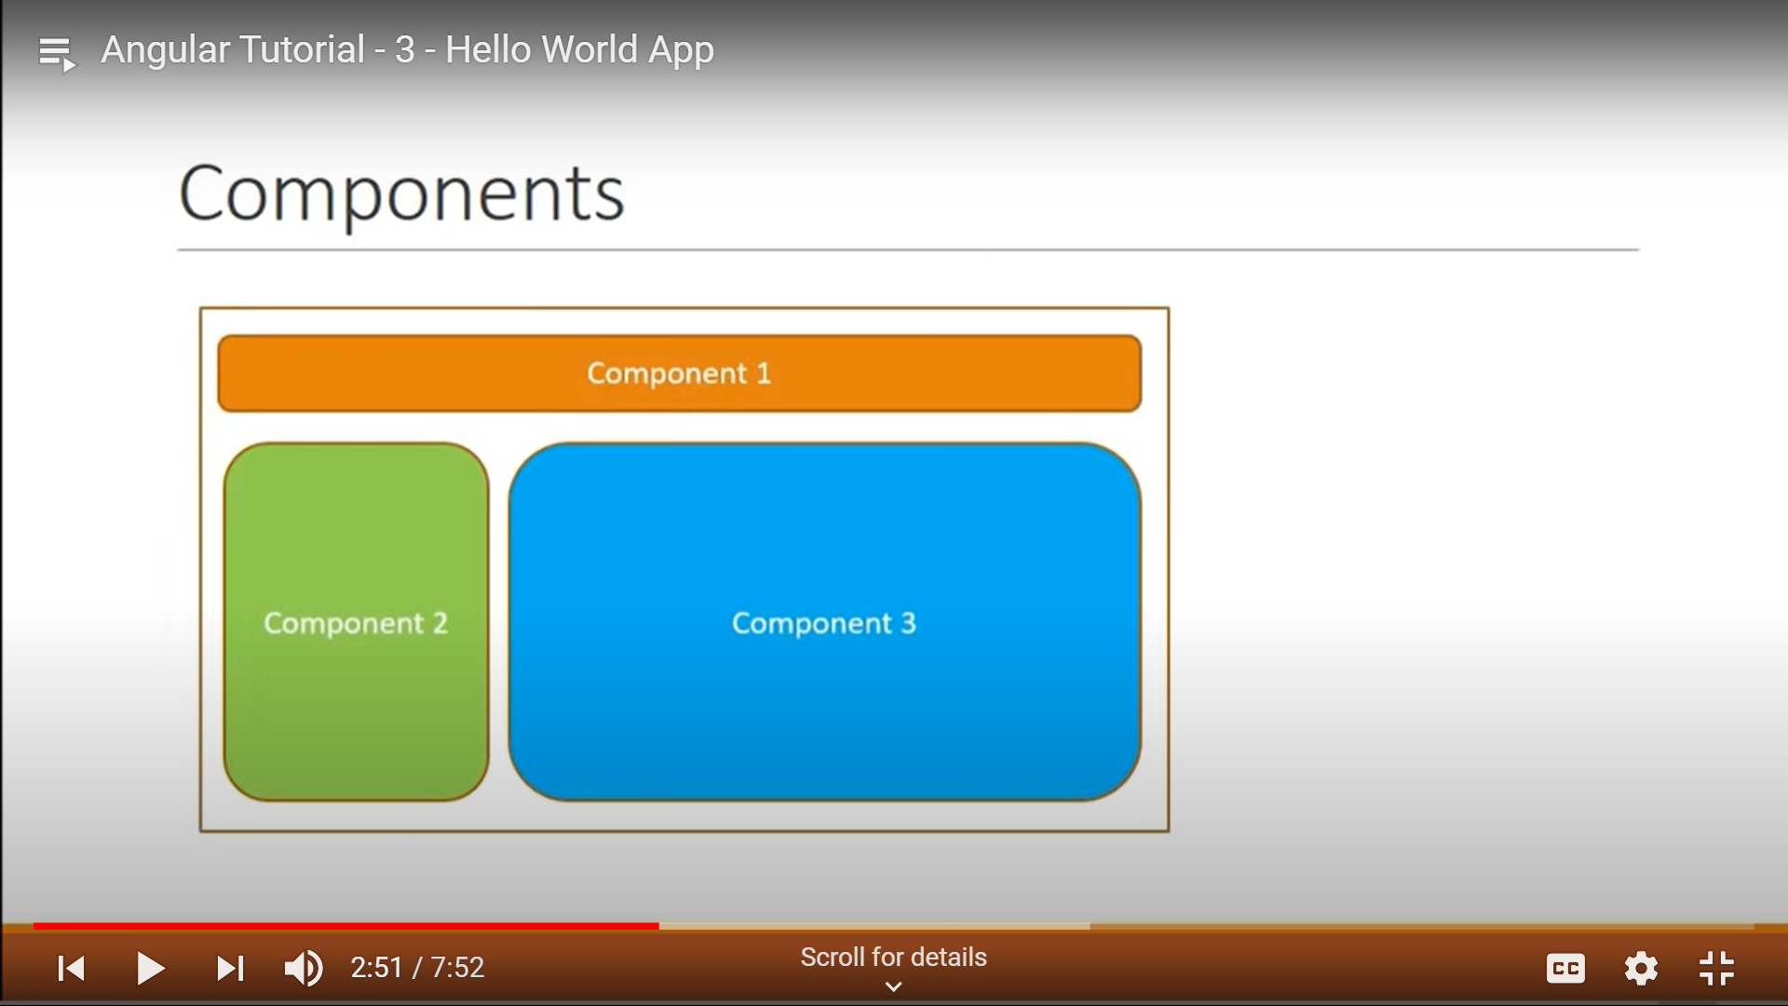

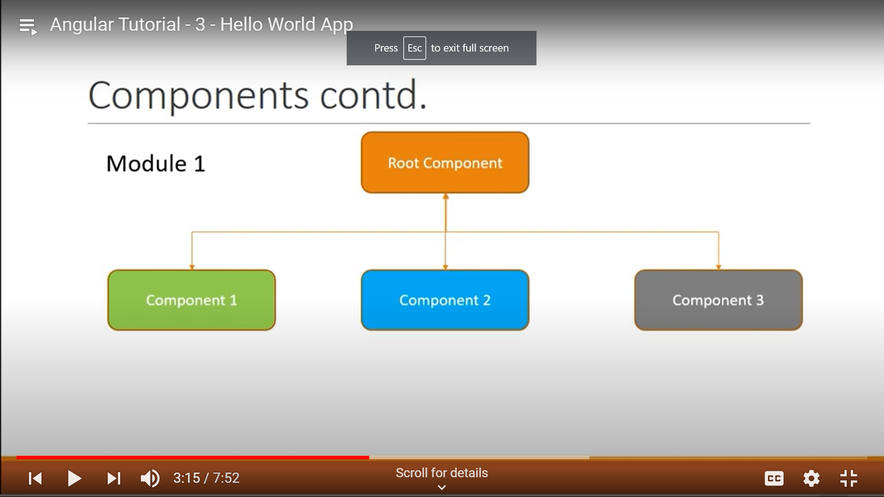

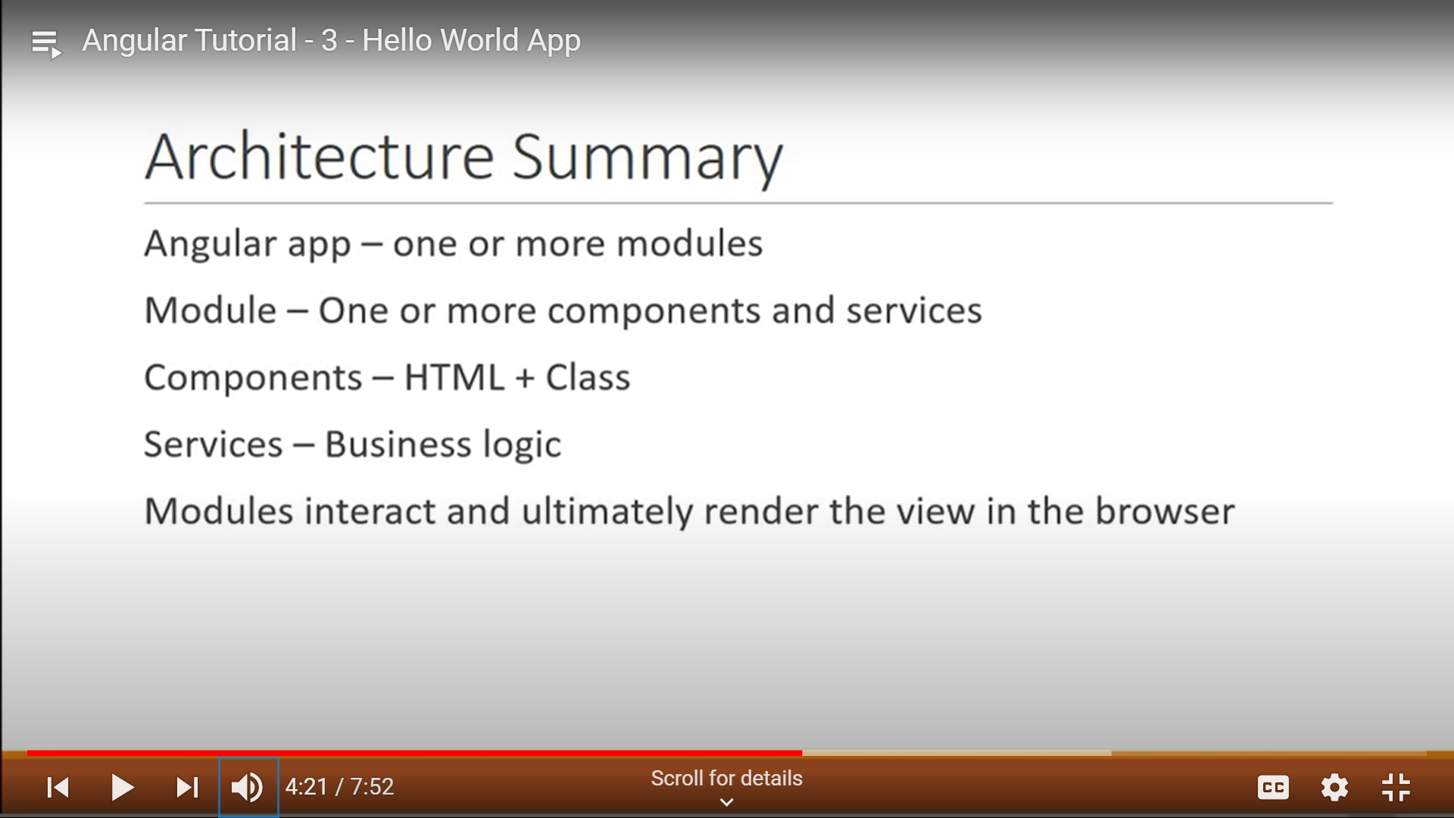

Component in Angular:

Component is building block of an application

Component is combination of three things.

1.Template 2. Class 3. Metadata.

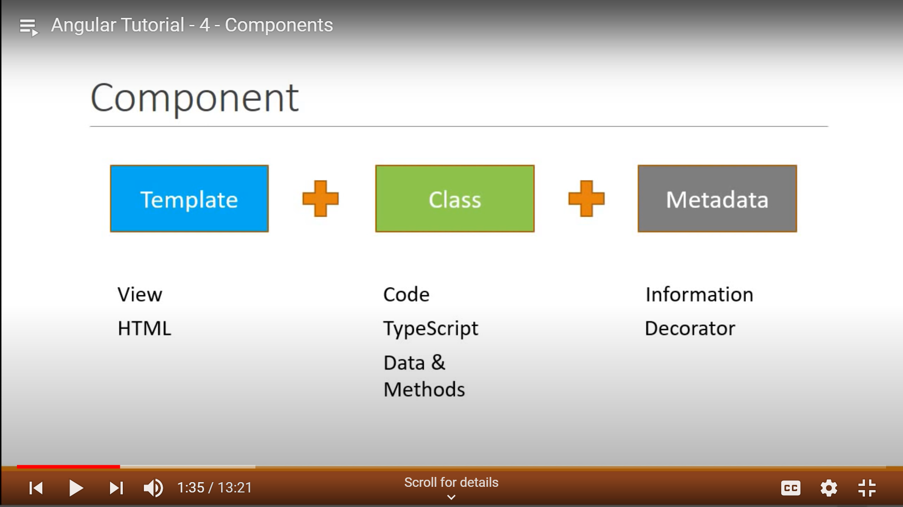

To create any component the command is **ng g c [component name]**

g : generate c : component

There are 3 ways to specify selector.

1. Selector: ‘ name of selector] (custom element tag)
2. Selector:’.name of selector] (class attribue by adding . at the first)
3. Selector: ‘[name of selector] ( using square brackets)

When you use the first way we need to specify the selector in the app.component.html

1. <nameofselector></nameofselector>

2. <div class = “app-test”>

</div>

3. <div app-test>

</div>

In the component it is possible to write inline template i.e. in the same typescript file for that we can use template property.

For single line html code need to use single code ex: <div>Hello how are you </div>

We can use backtik(`) for multiple lines of html

It is same for styles as well but only one change is need to write in an array.

Ex: styles : [`

div {

color:red

}

`]

**Inrerpolation:**  it is the process where we can display the value to the template view from class using double curly braces ({}). And we can define in another way like it is the process of binding the data from class to template.

We can use curly braces for evaluate an expression and concatenation ex: {{2+3}}, {{“welcome”+[bindingvariable]}}

Built in java script functions. Ex : {{name.length}}, {{name.toUpperCase}}

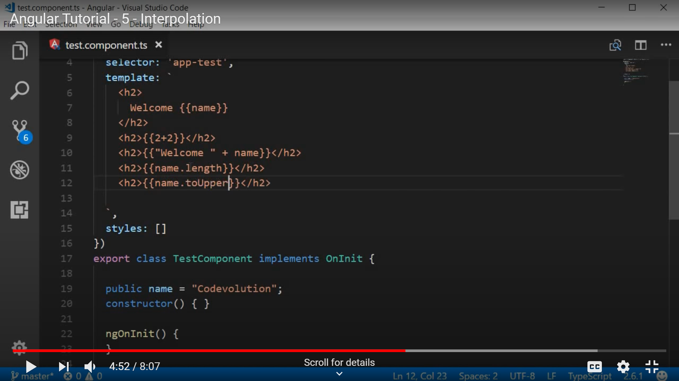

We can call component class methods in the template using curly braces: {{greetFunction()}}

greetFunction()

{

xxxxxx

}

We cannot assign expression result to variables. Ex : {{a = 2+4}} and we cannot access global java script variables like window and screen. But we can access it in the class and bind to the template

**Property Binding:**

**HTML Attribute vs DOM Property**

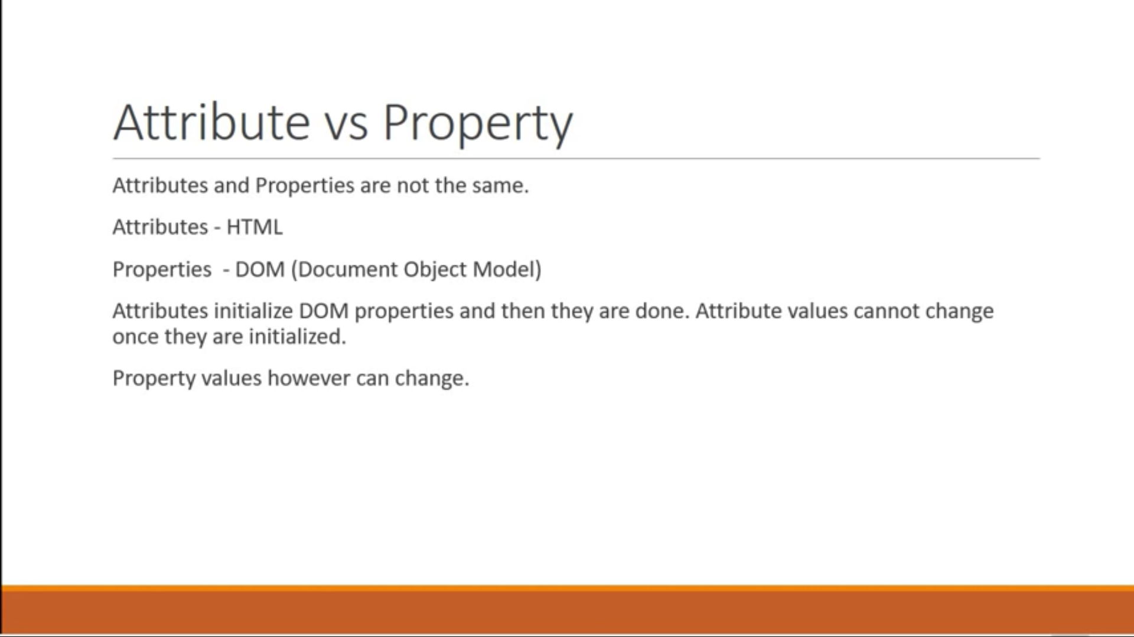

The difference between interpolation and property binding is interpolation supports only String datatype. It will not support Boolean datatype.

We can use square brackets to property binding or bind-attribute name.

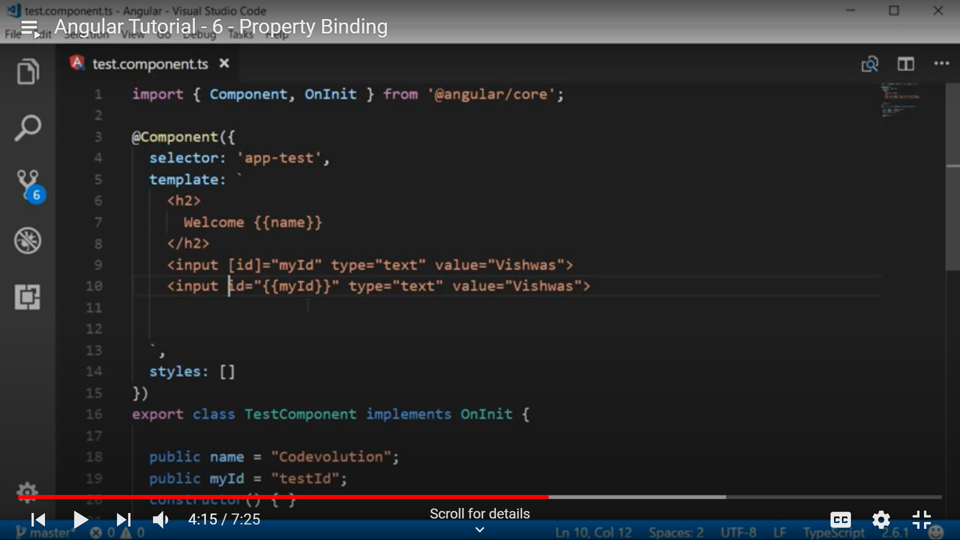

**Class Binding:**

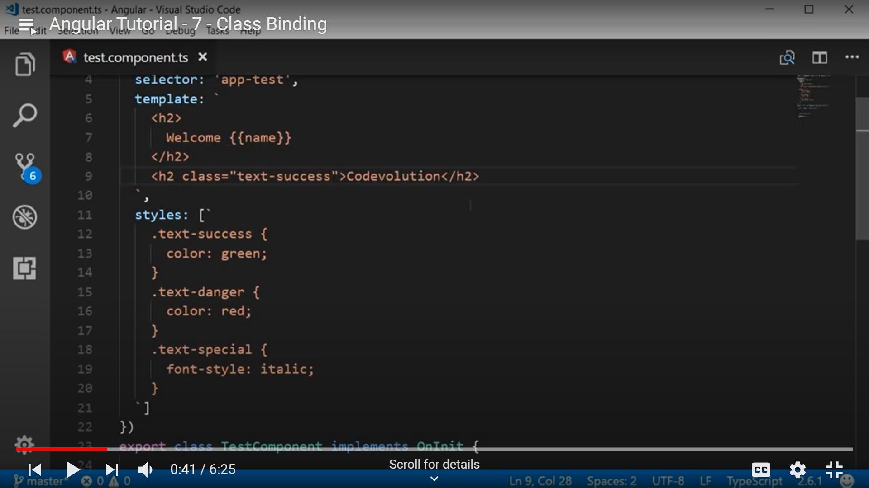

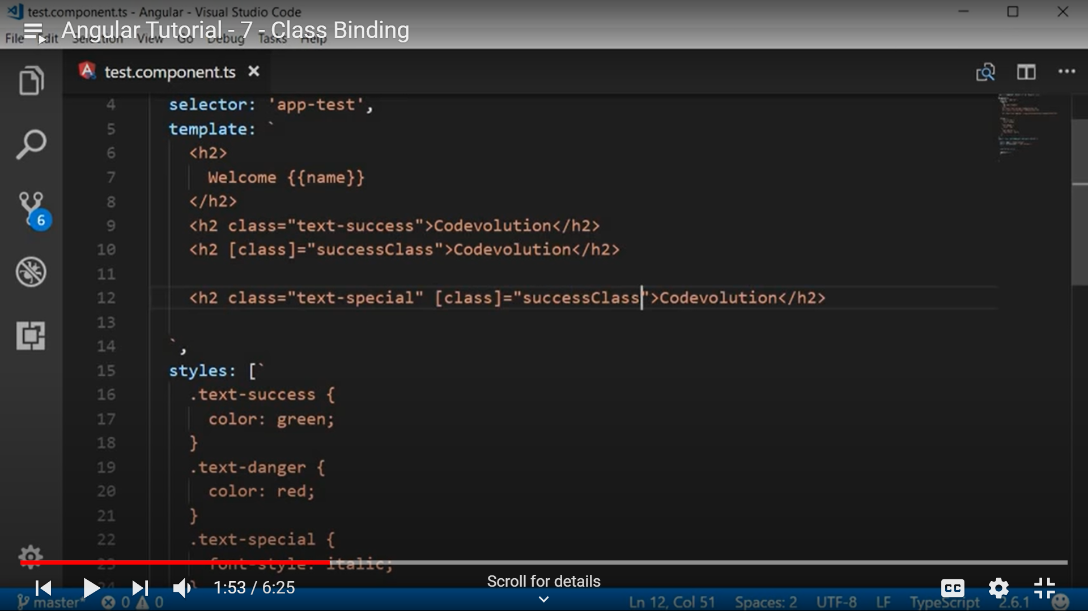

When you use both class attribute and class binding, class binding will override the class attribute.

We can assign evaluation property to class binding.

Below is the example when you want to apply condition for single class.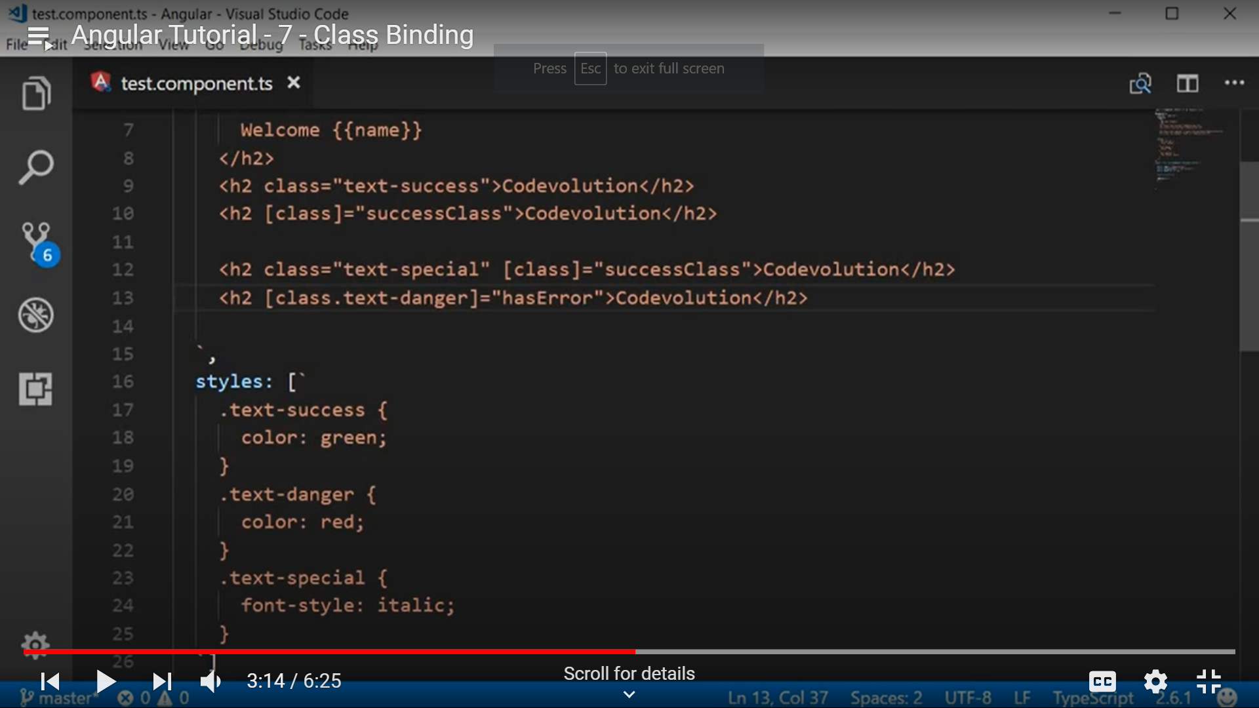

If you want to apply condition for multiple classes we can use ngClass directive which is custom html custom elements.

Below is the code for the same.

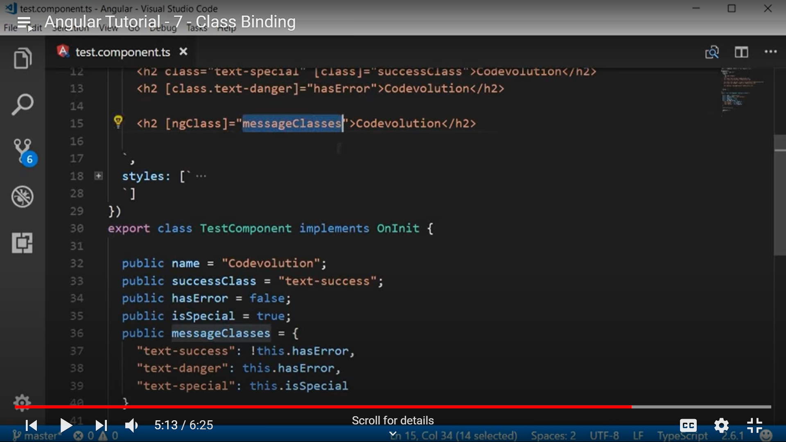

**Event Binding:**

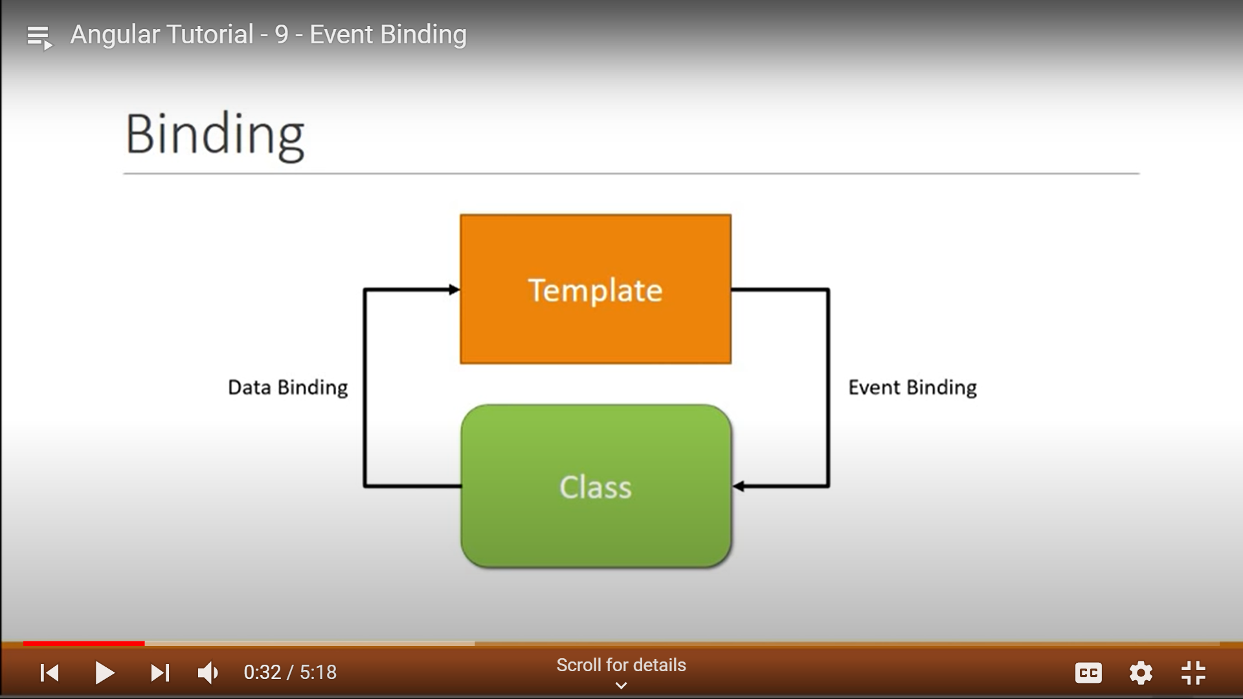

Mouse event click is an DOM event when you click on button event handler will get call if you want event information need to pass $even as a parameter.

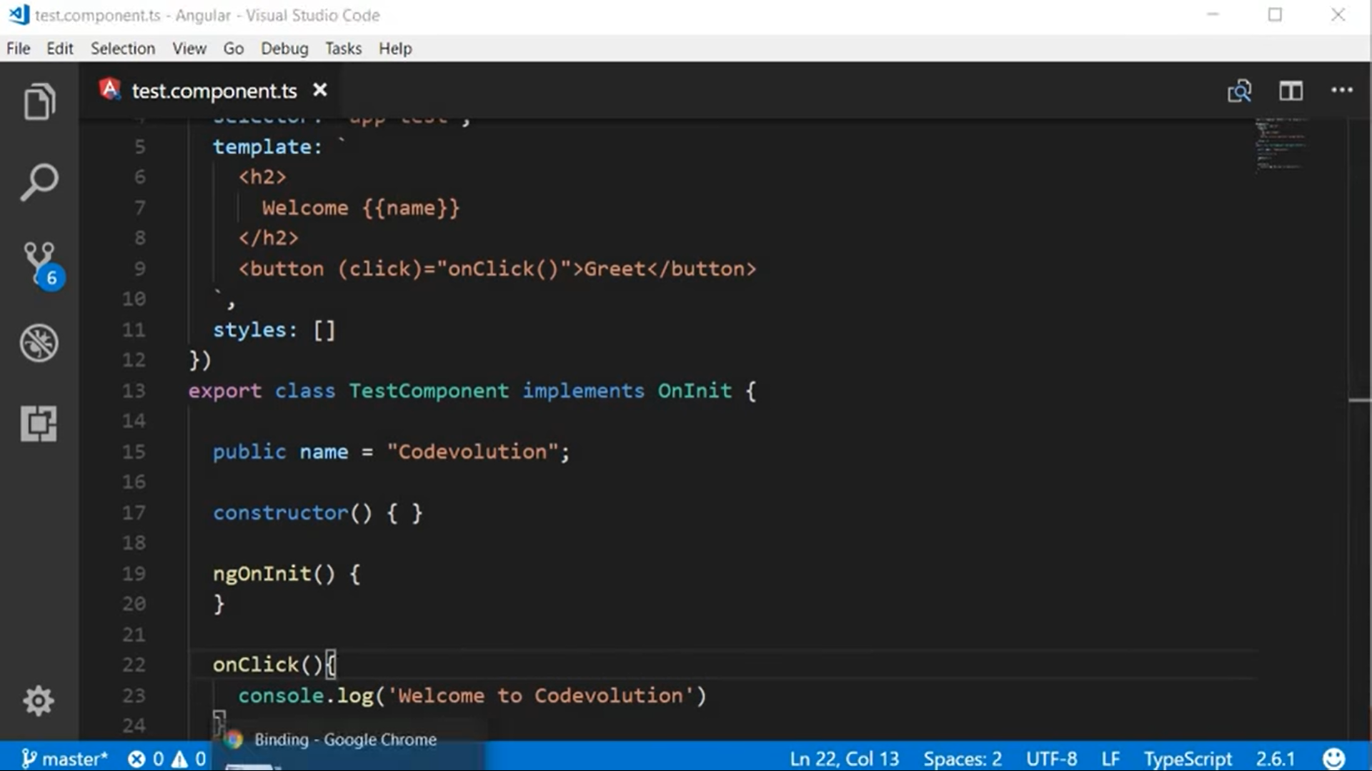

A separate event handler may not be necessary followed by event Ex: below

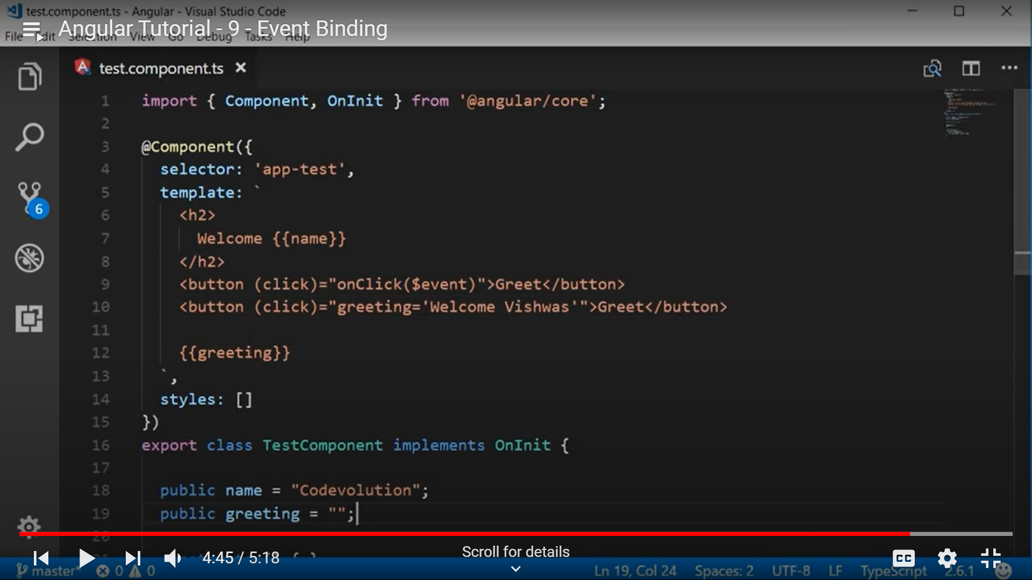

**Template Reference:**

If you want to validate the inputs from the UI template reference is required. Syntax to template reference variable is # followed by name of the reference variable.

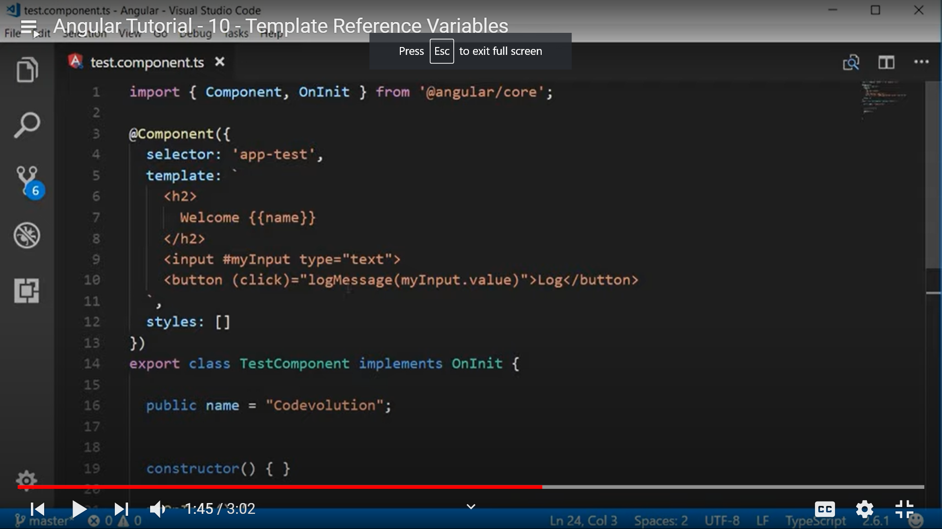

**Two way binding:**

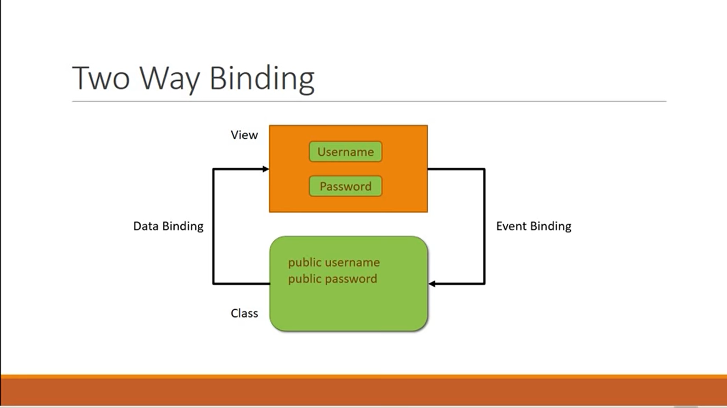

ngModel directive is used for two way binding. It is there in the forms module.

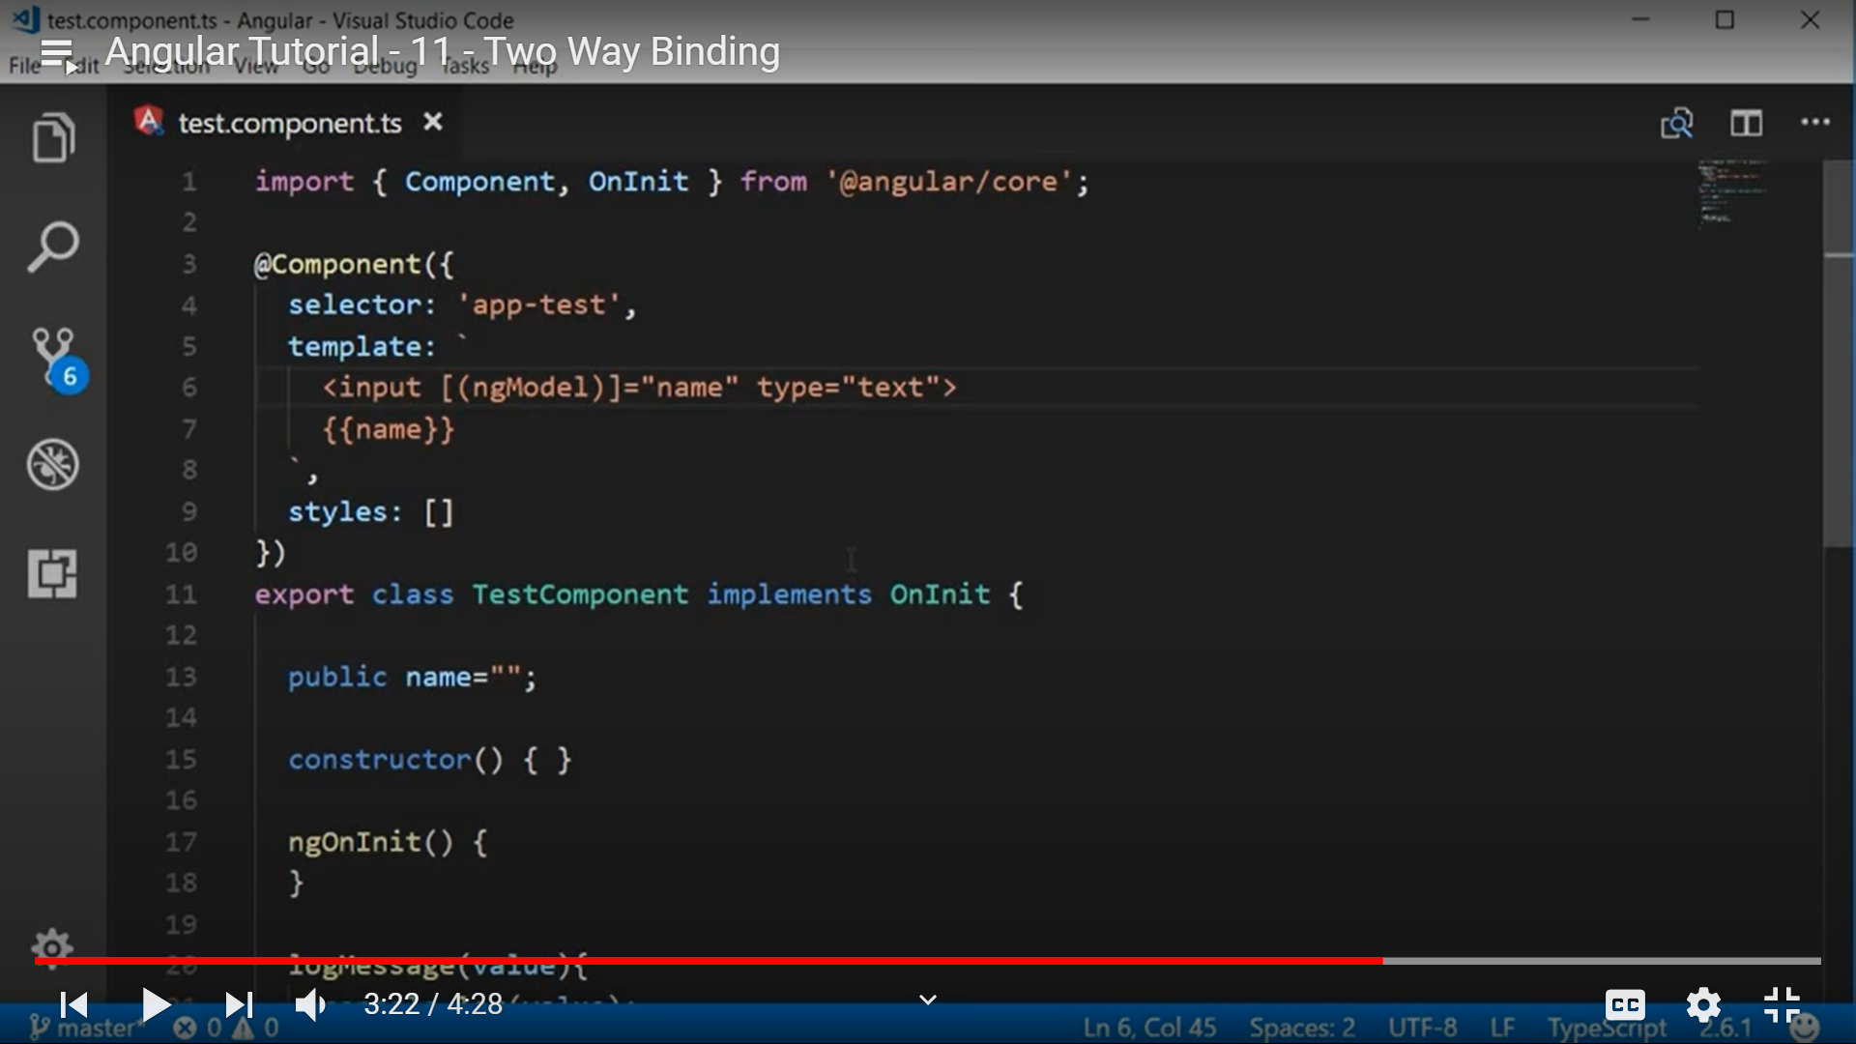

**Importing of forms module:**

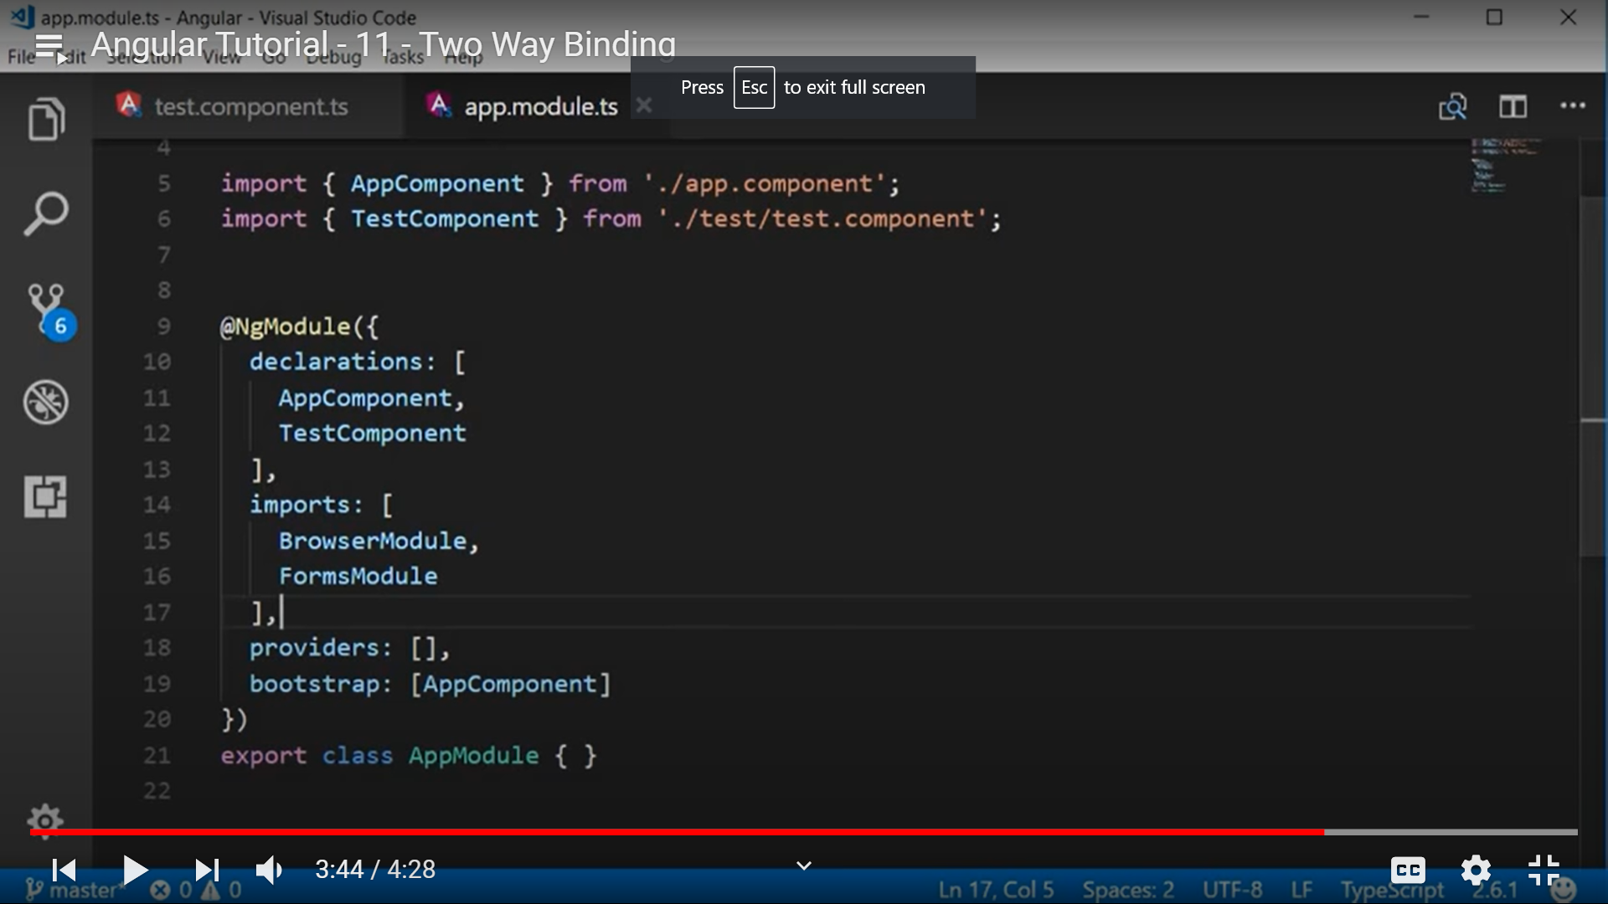

**Structural directives:**

These directives lets you add or remove HTML elements. There are three directives under structural directives.

1. ngIf

2. ngSwitch

3.ngFor

**Angular Routing:**

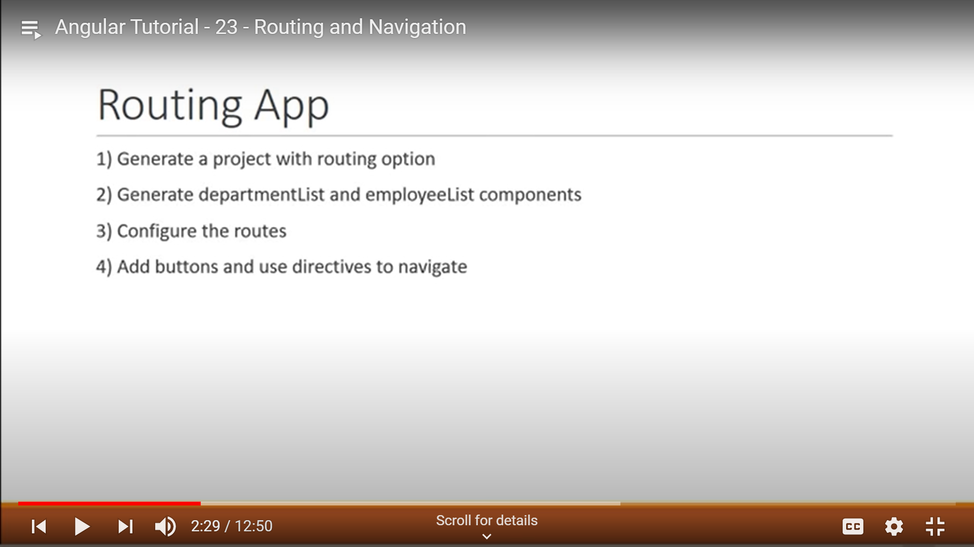

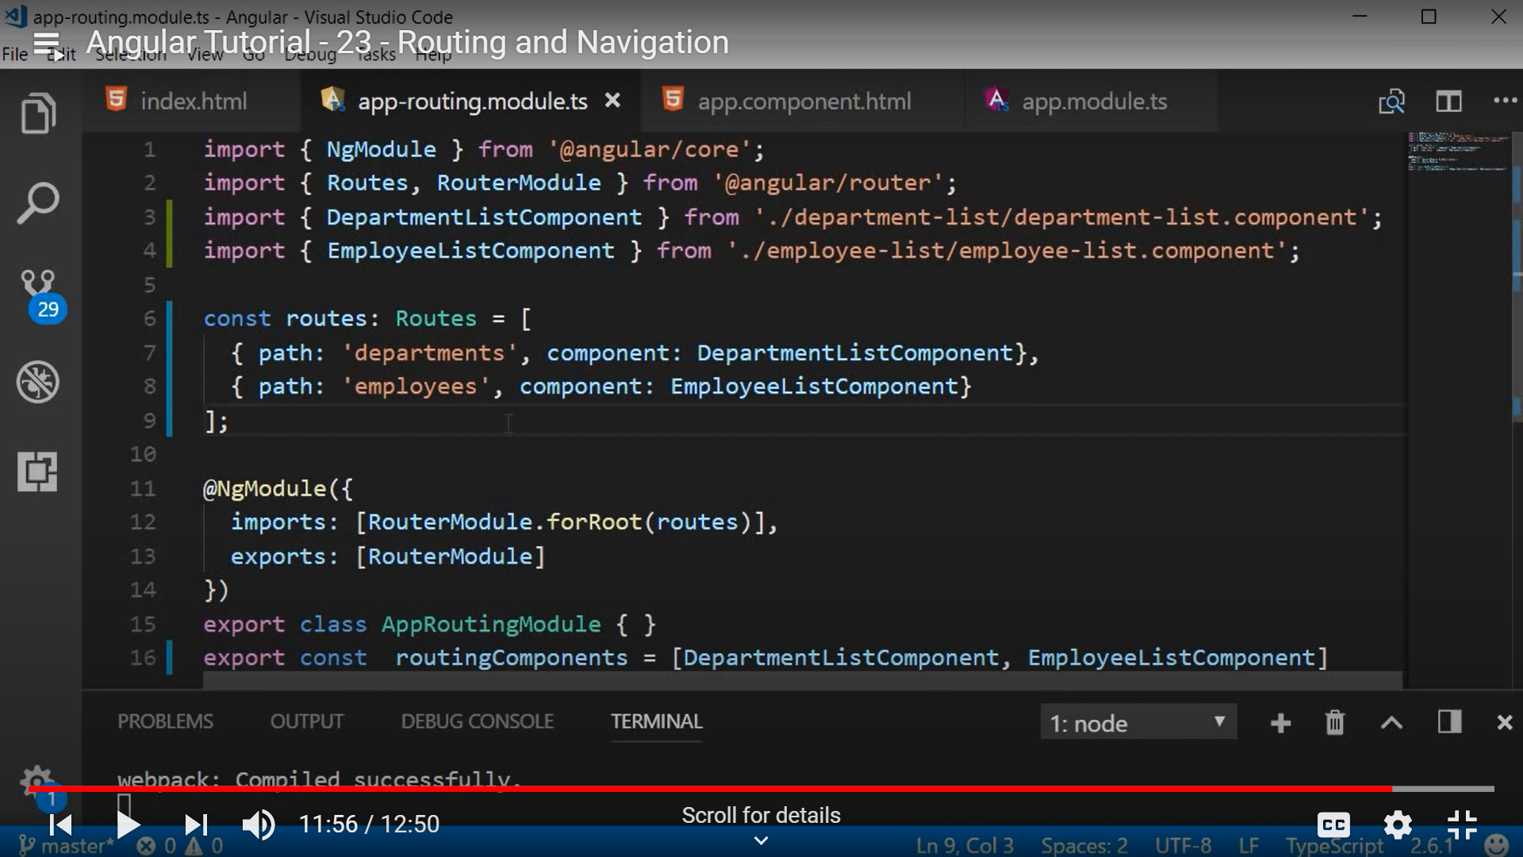

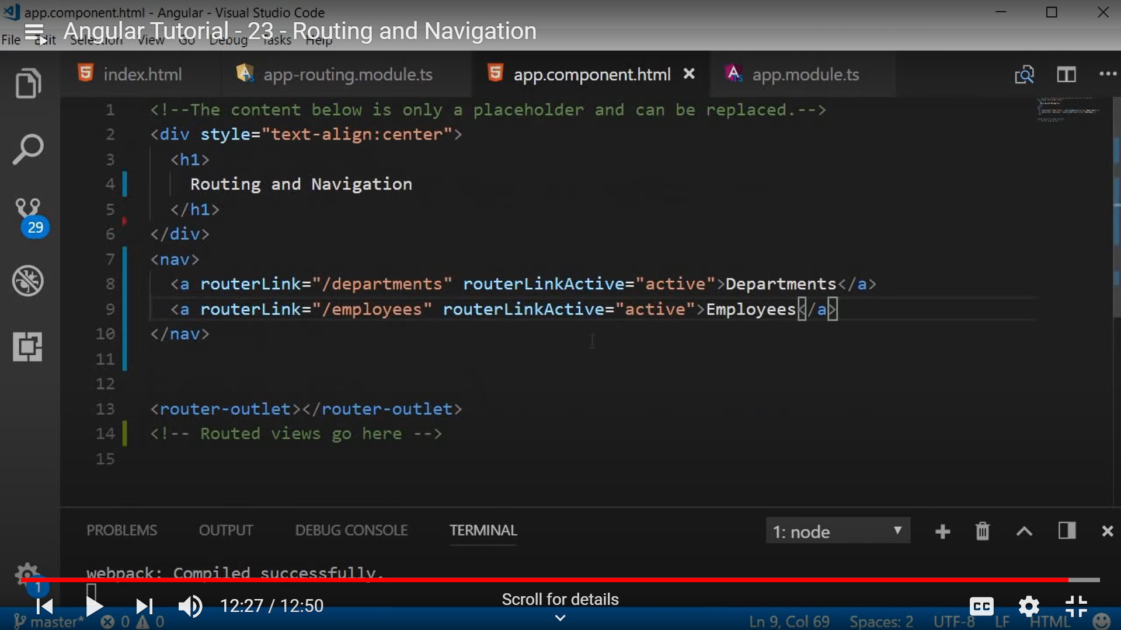

**Wildcard Routes:**

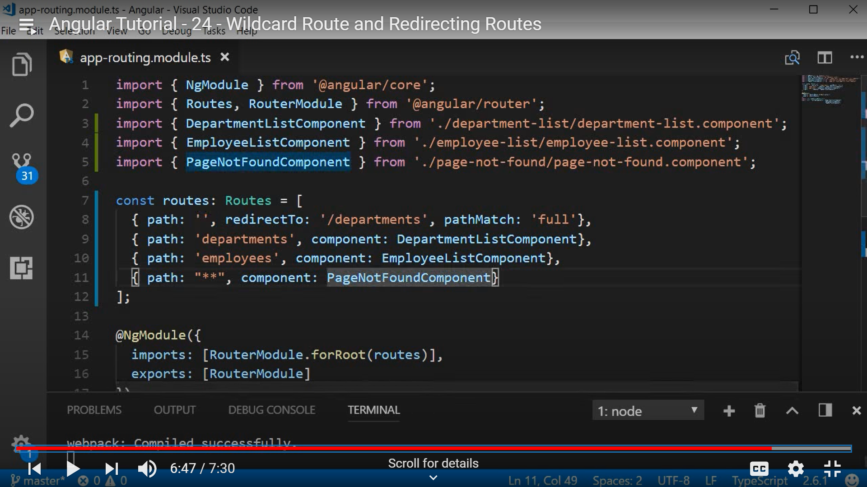

**Route Parameters:**

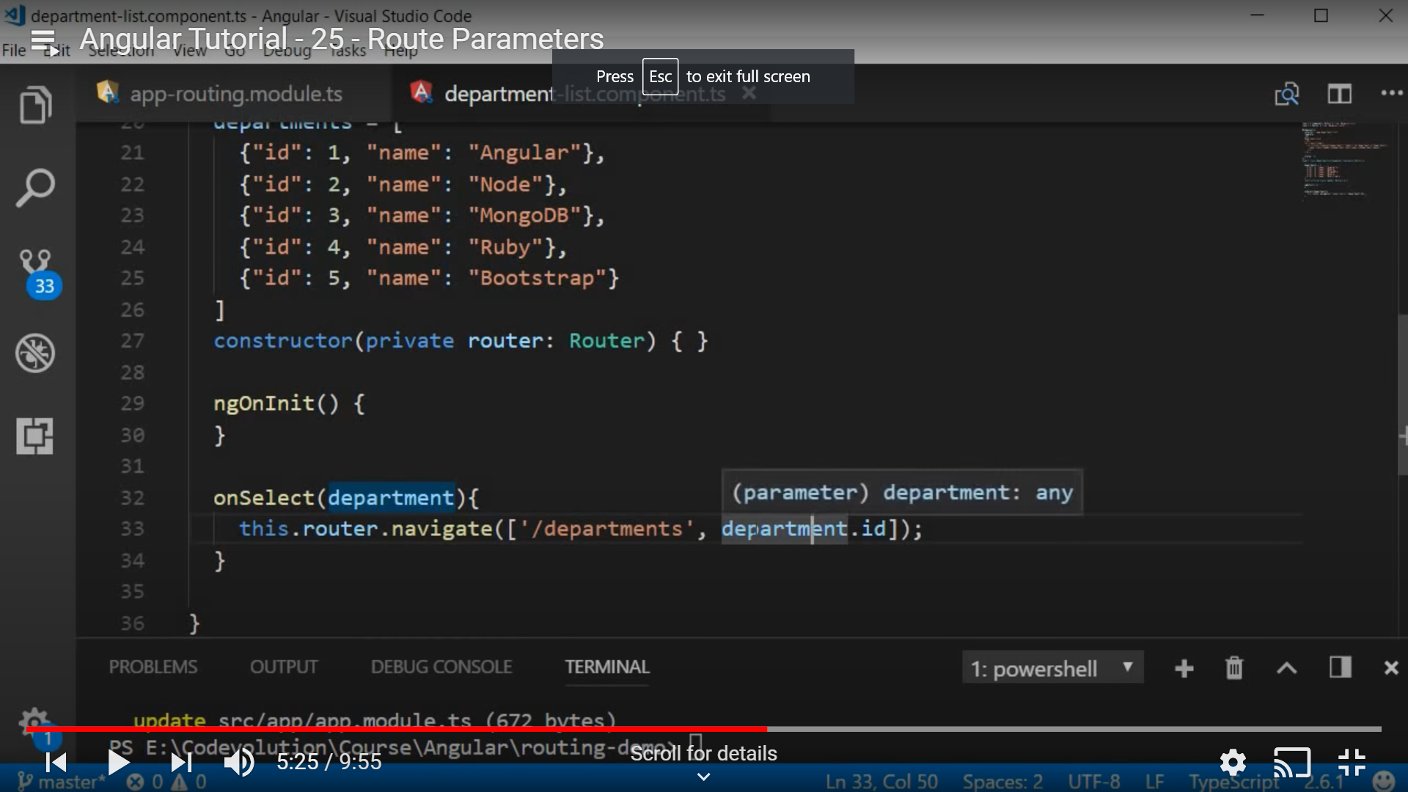

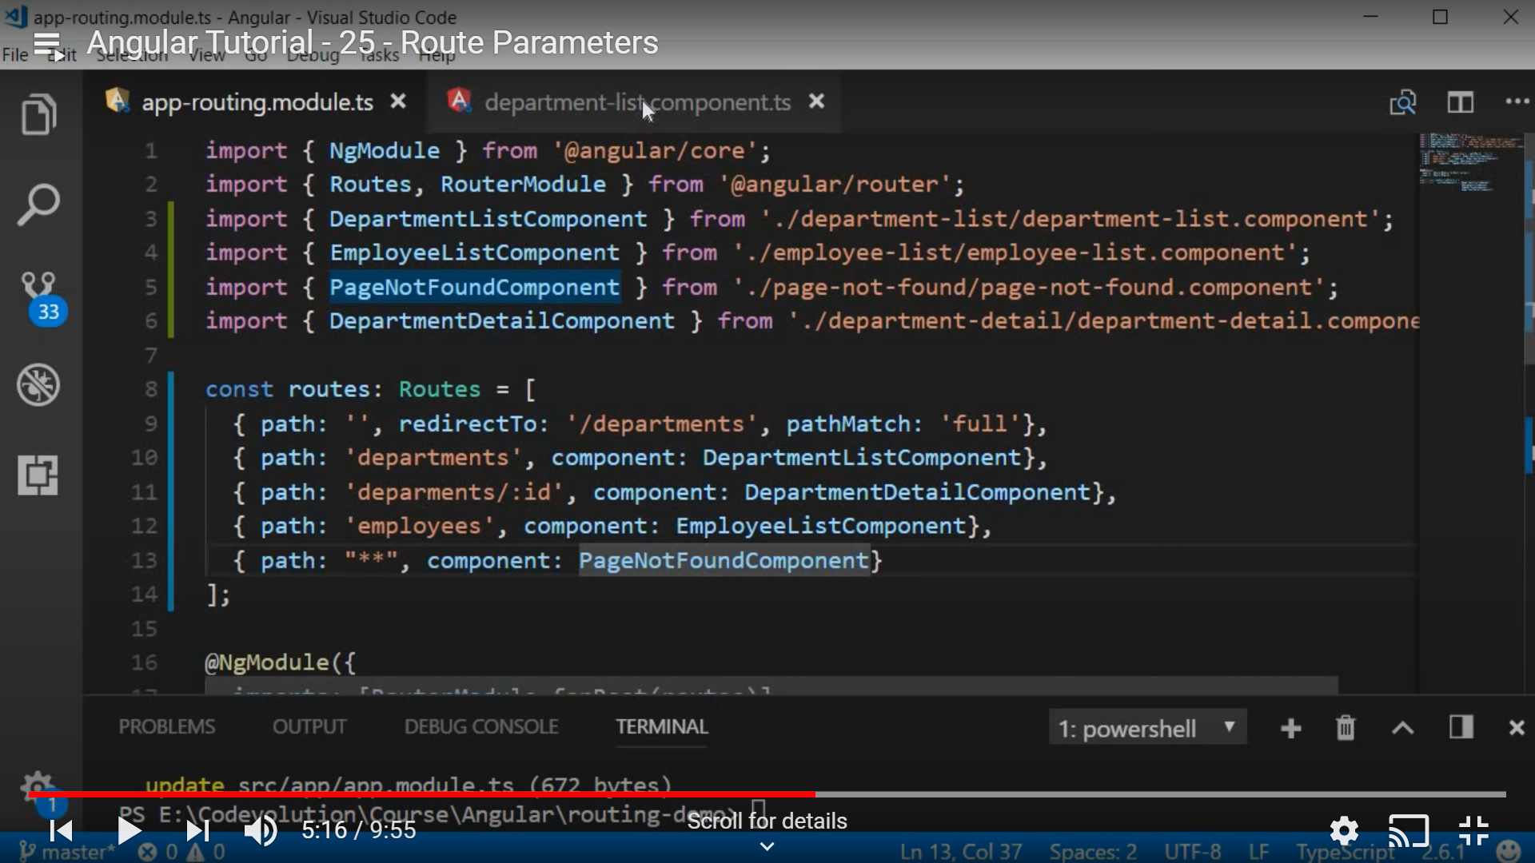

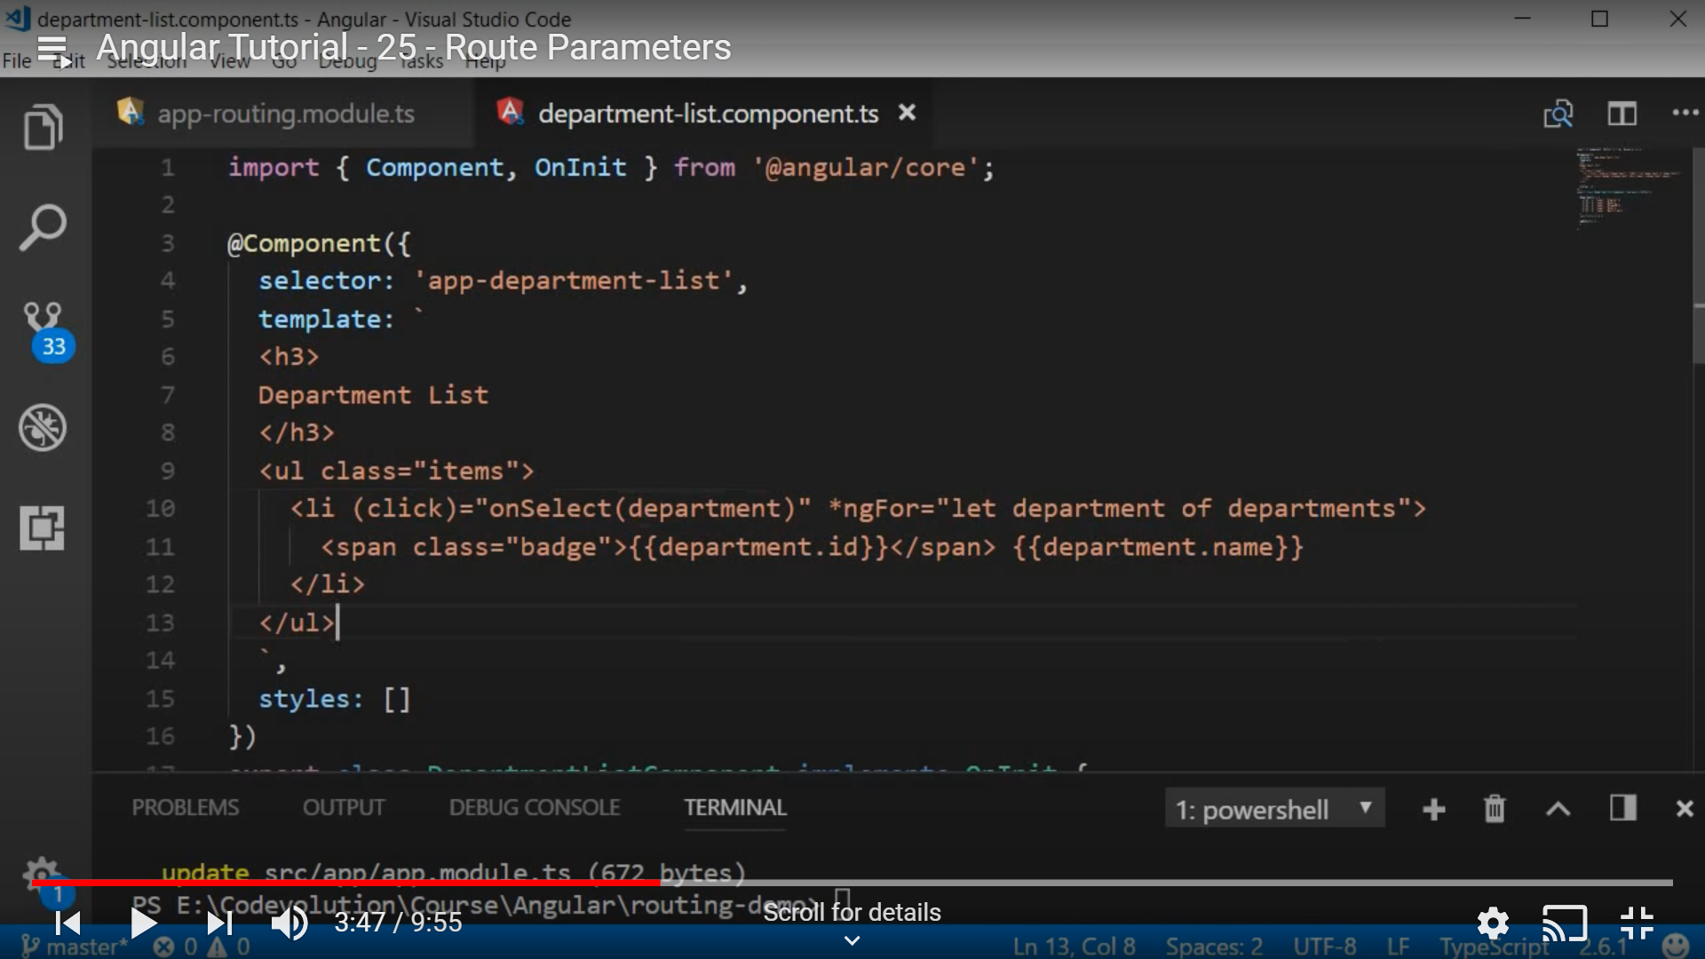

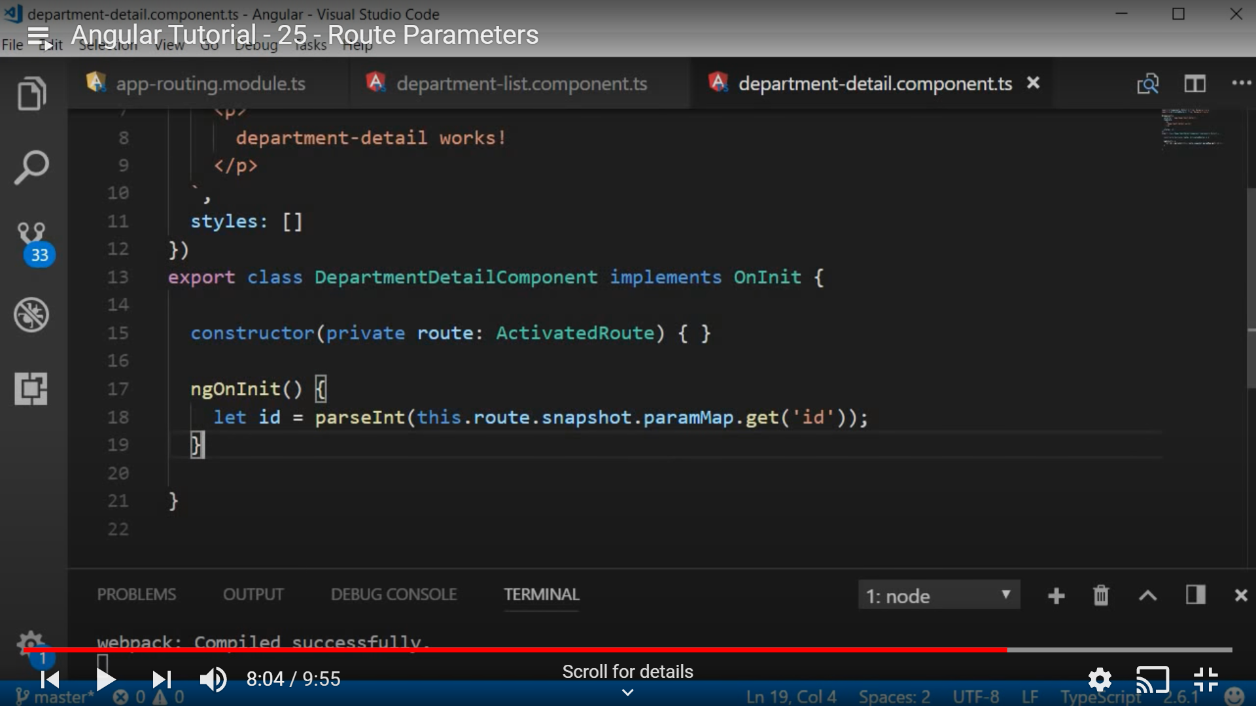

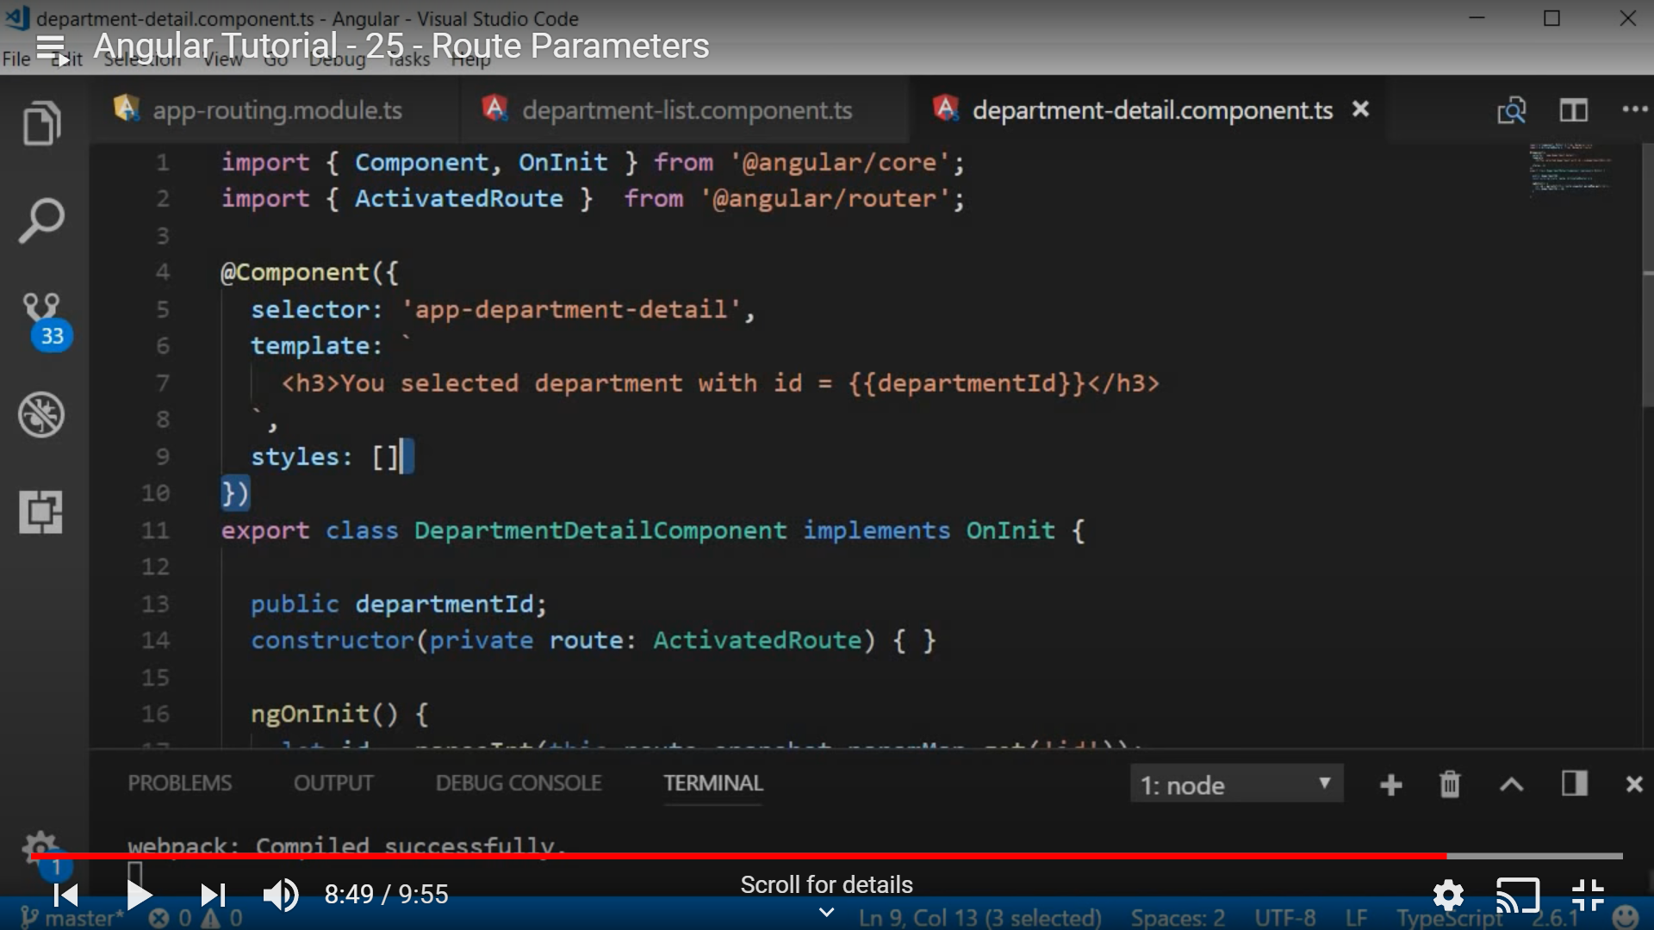

**Angular Forms:**

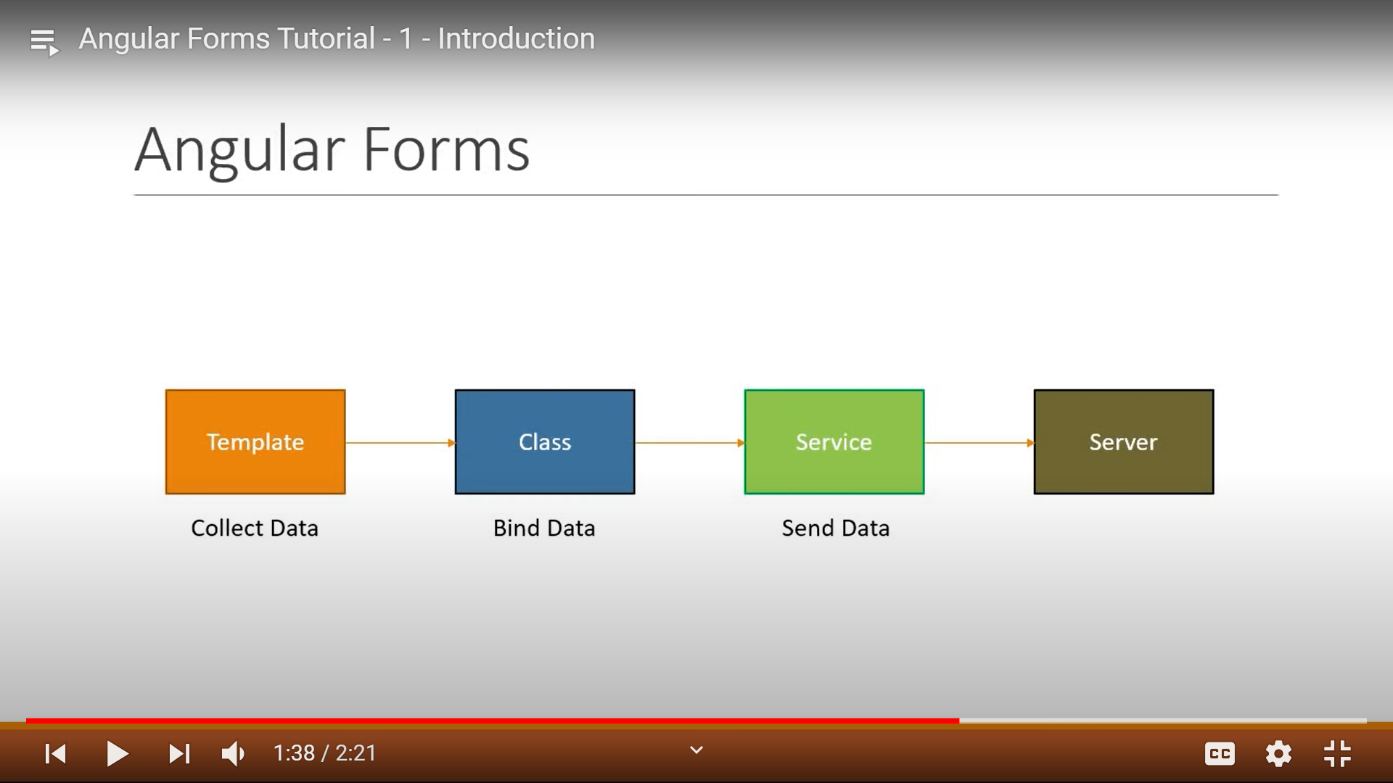

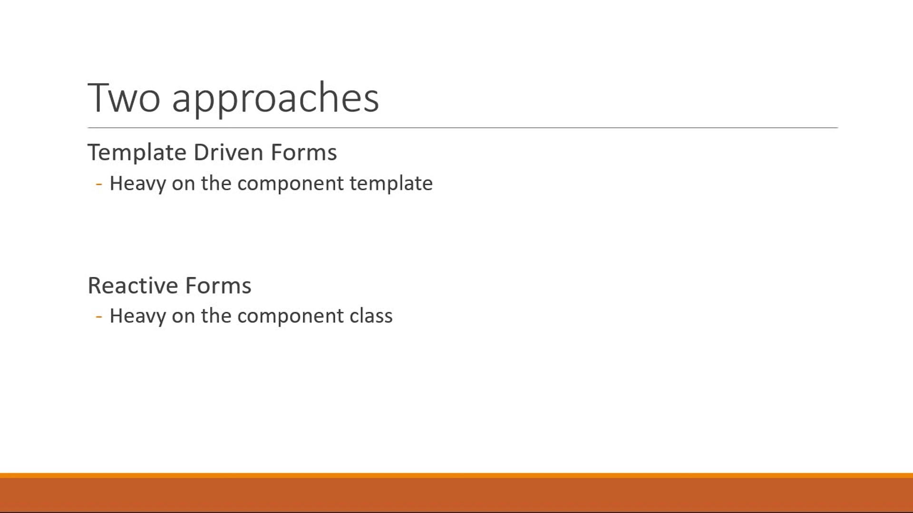

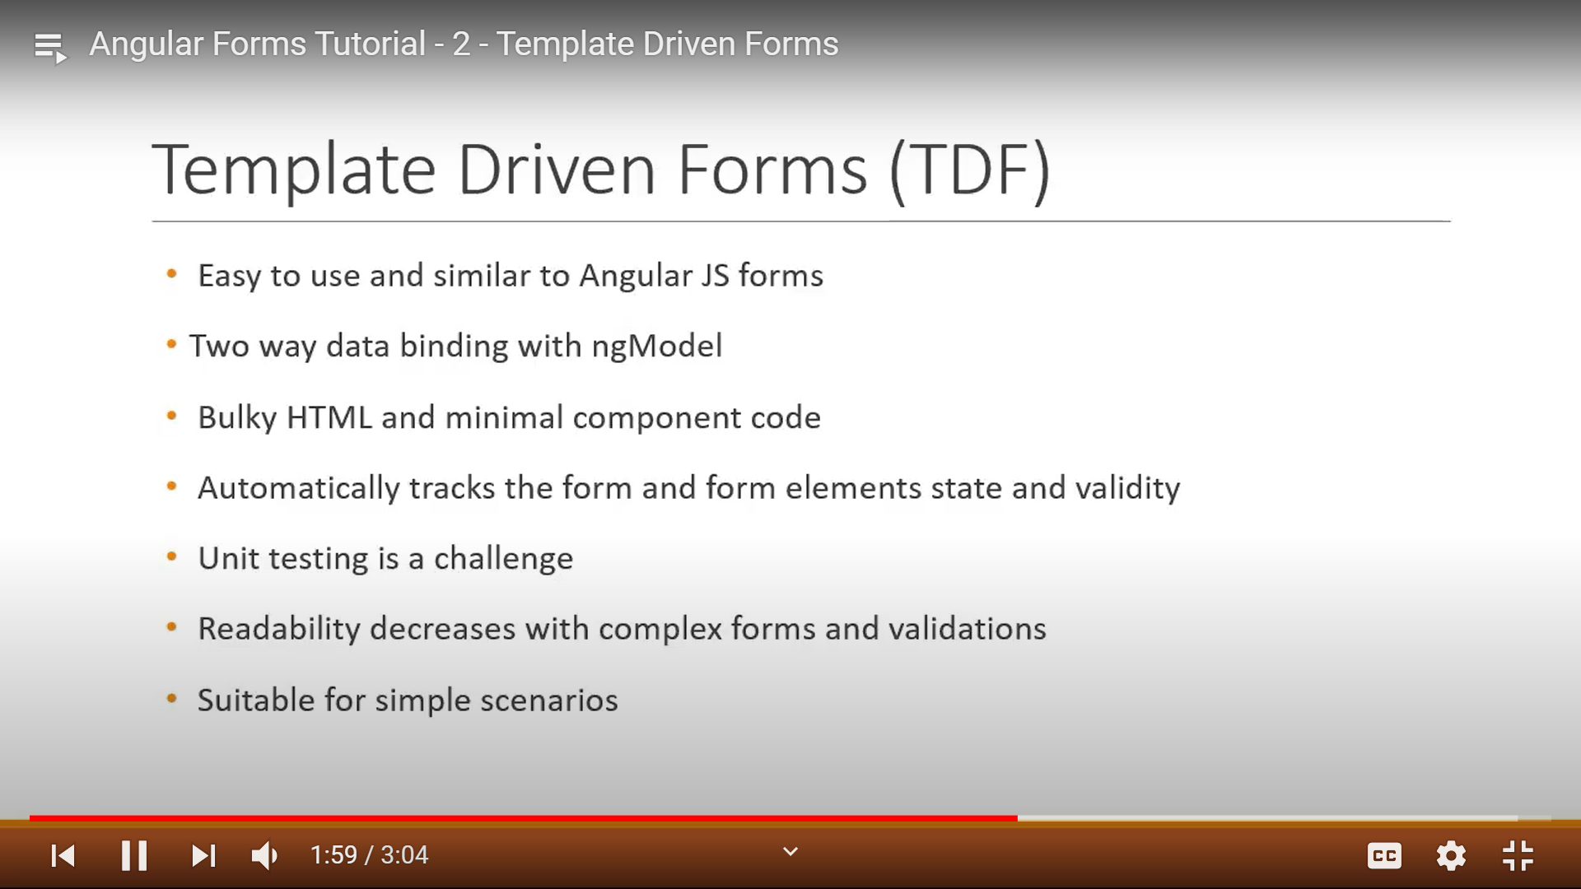

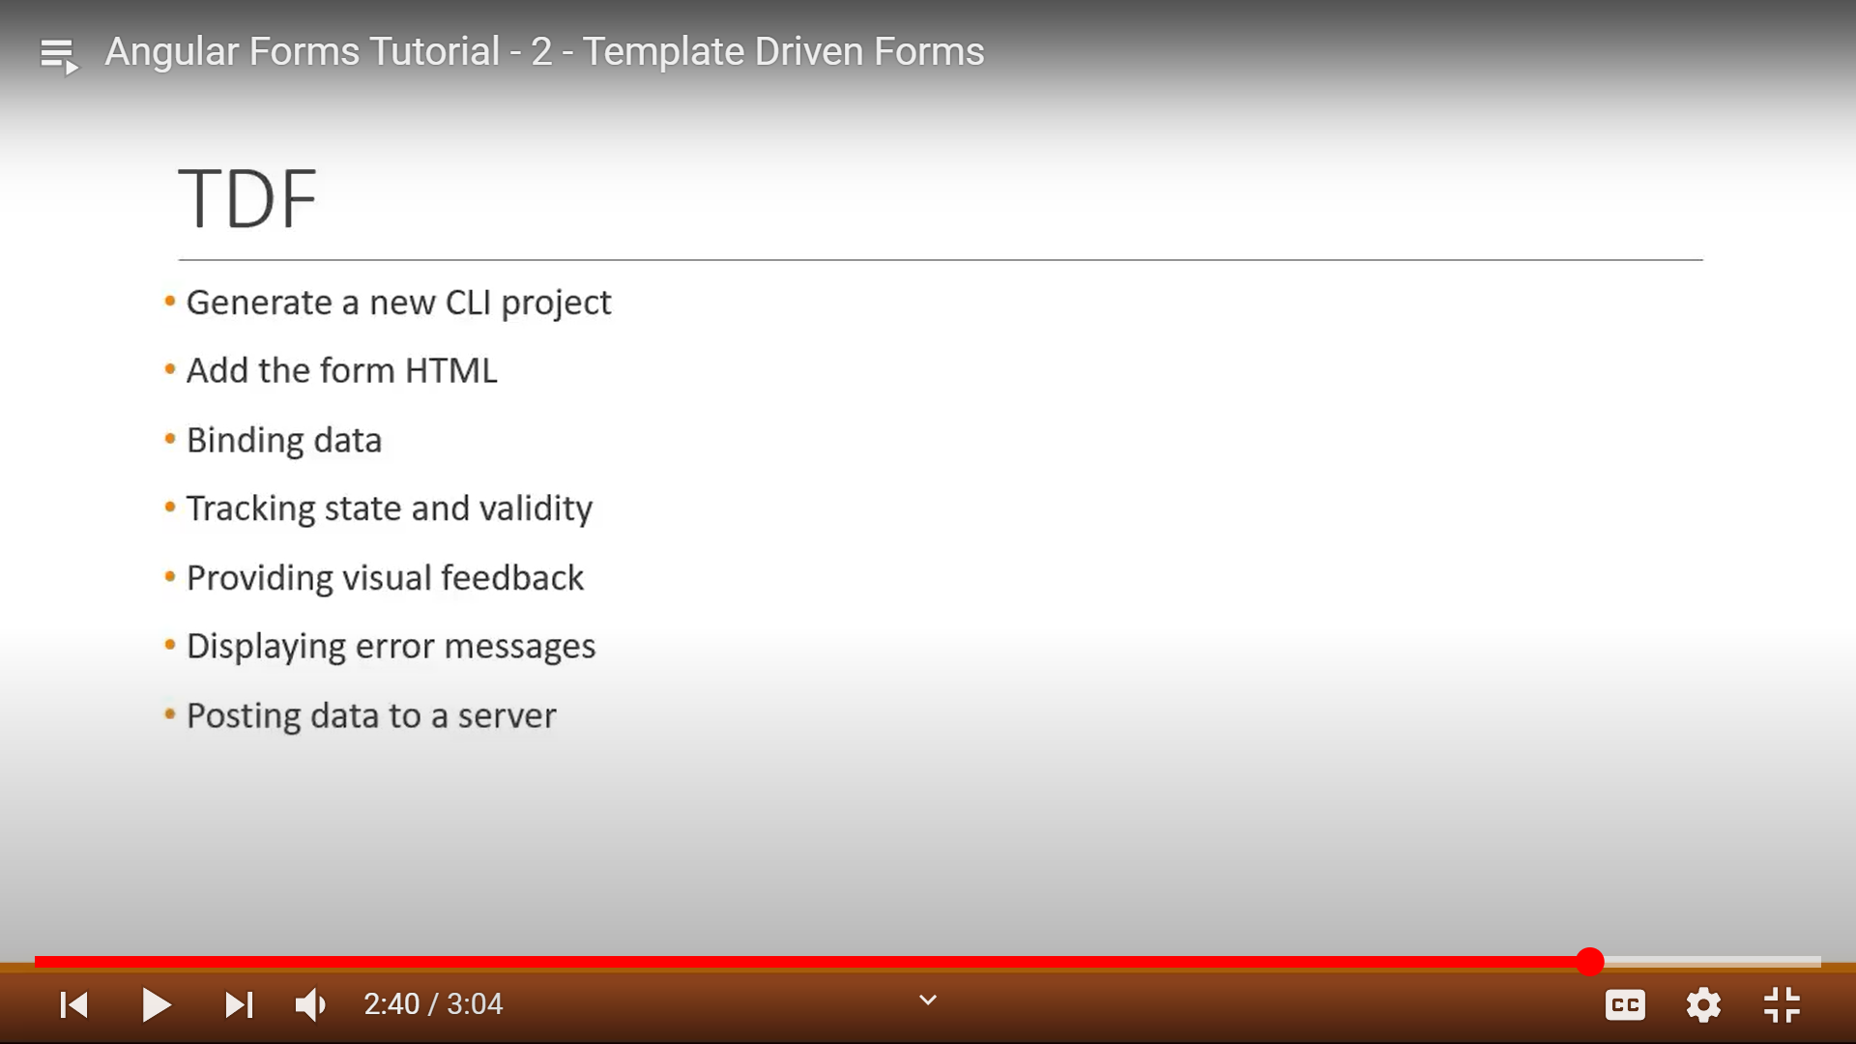

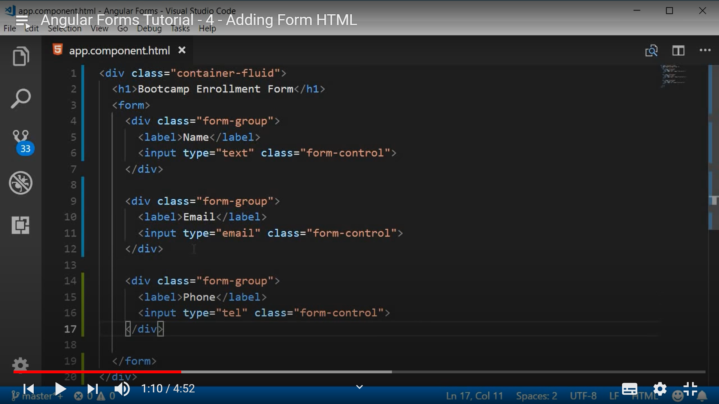

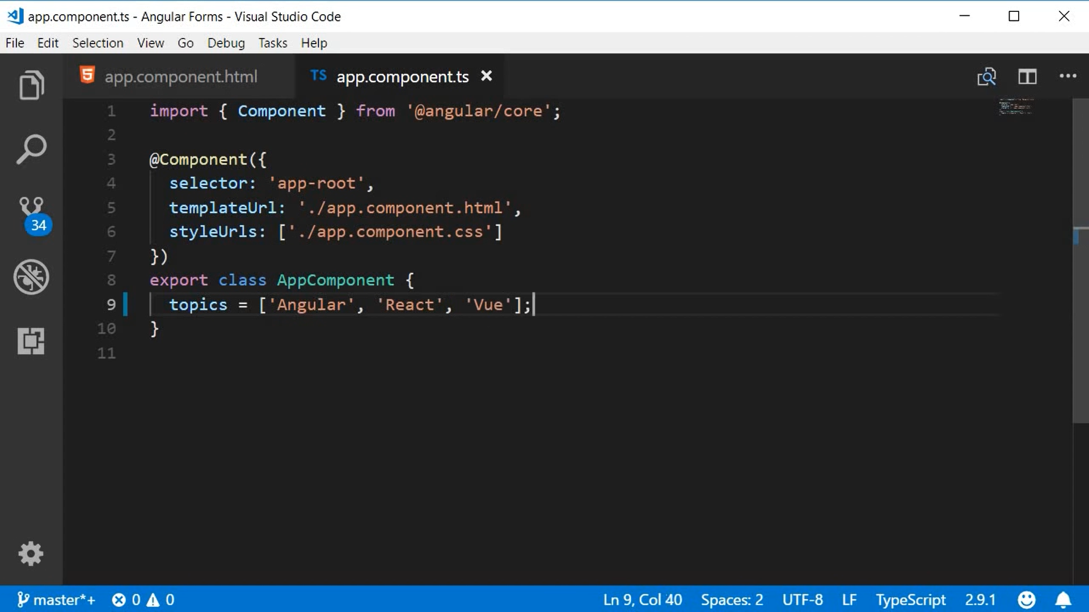

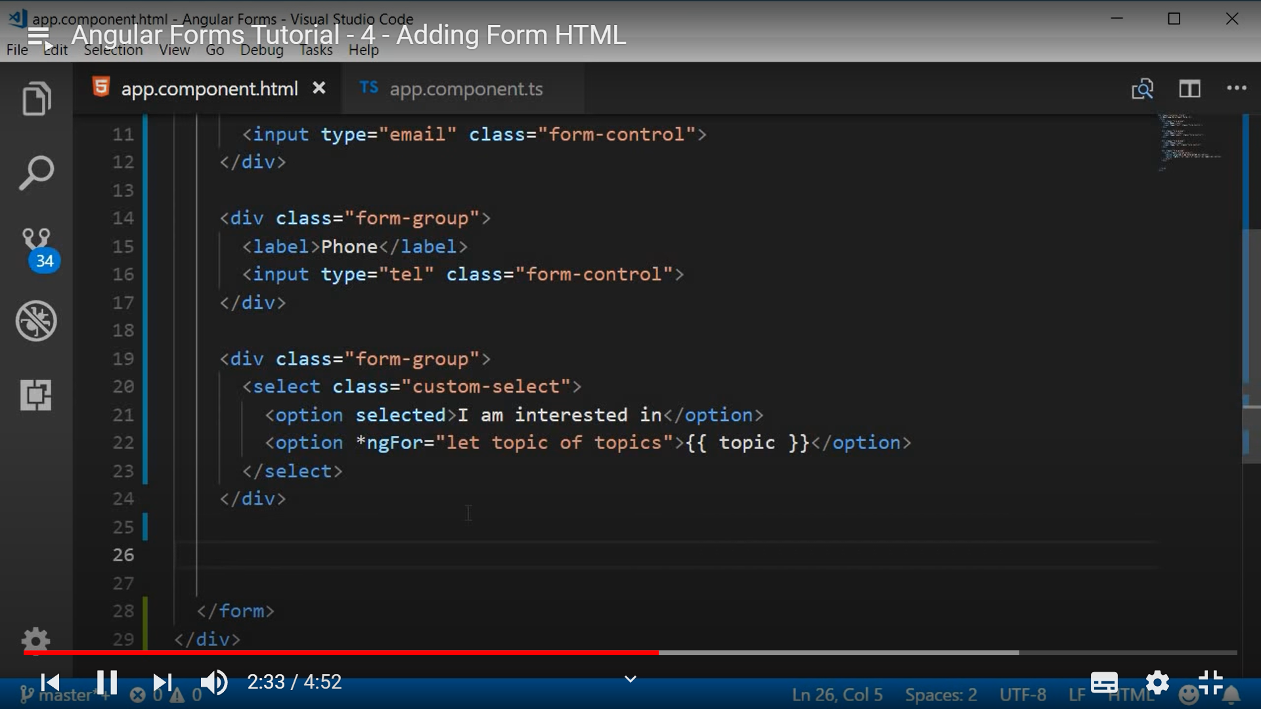

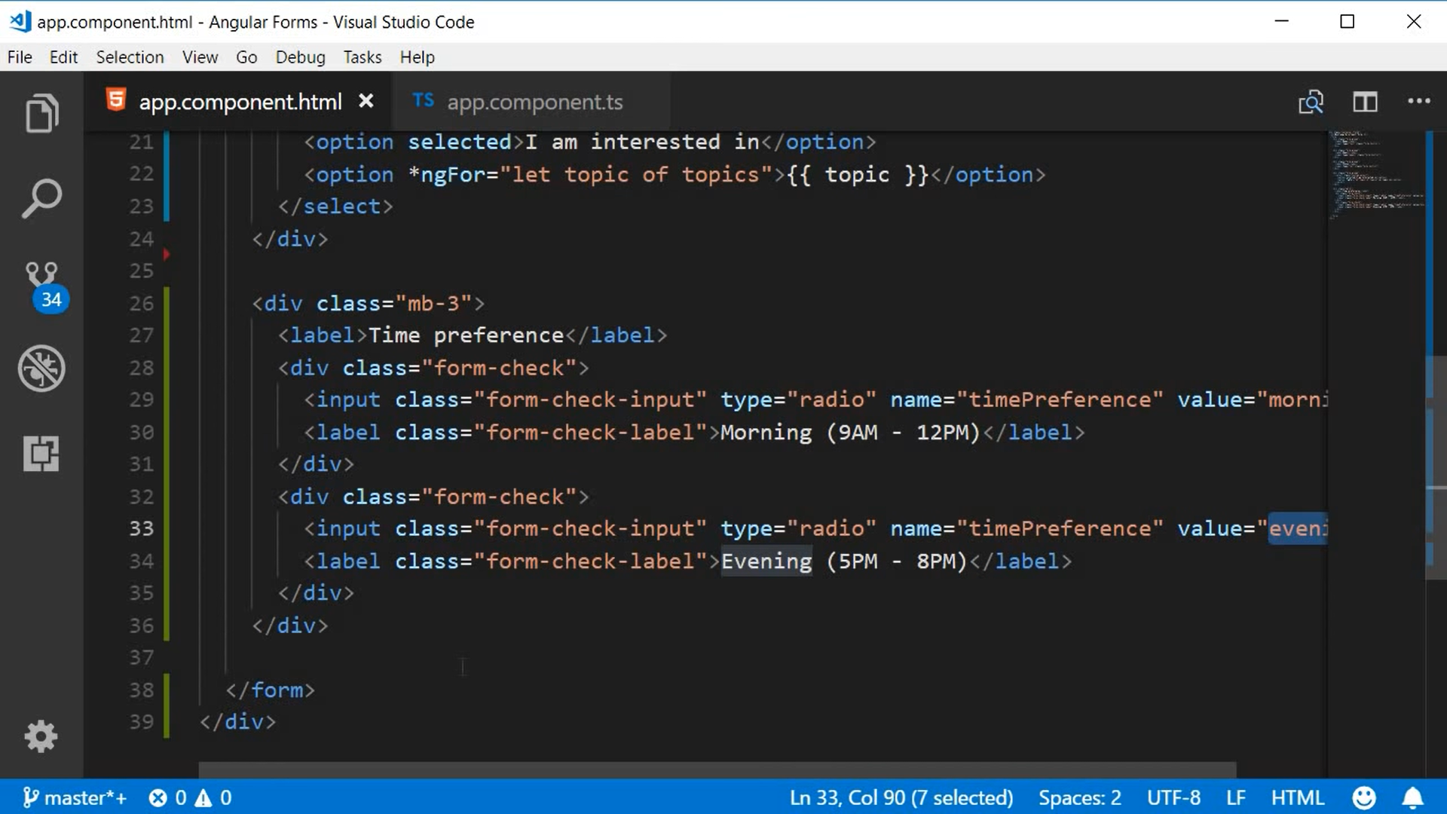

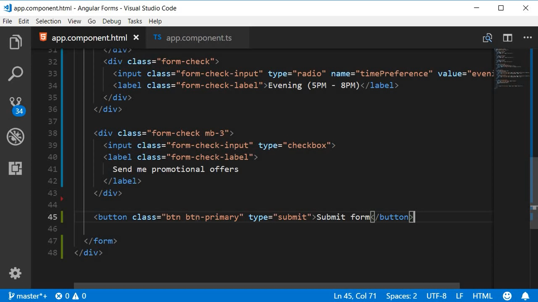

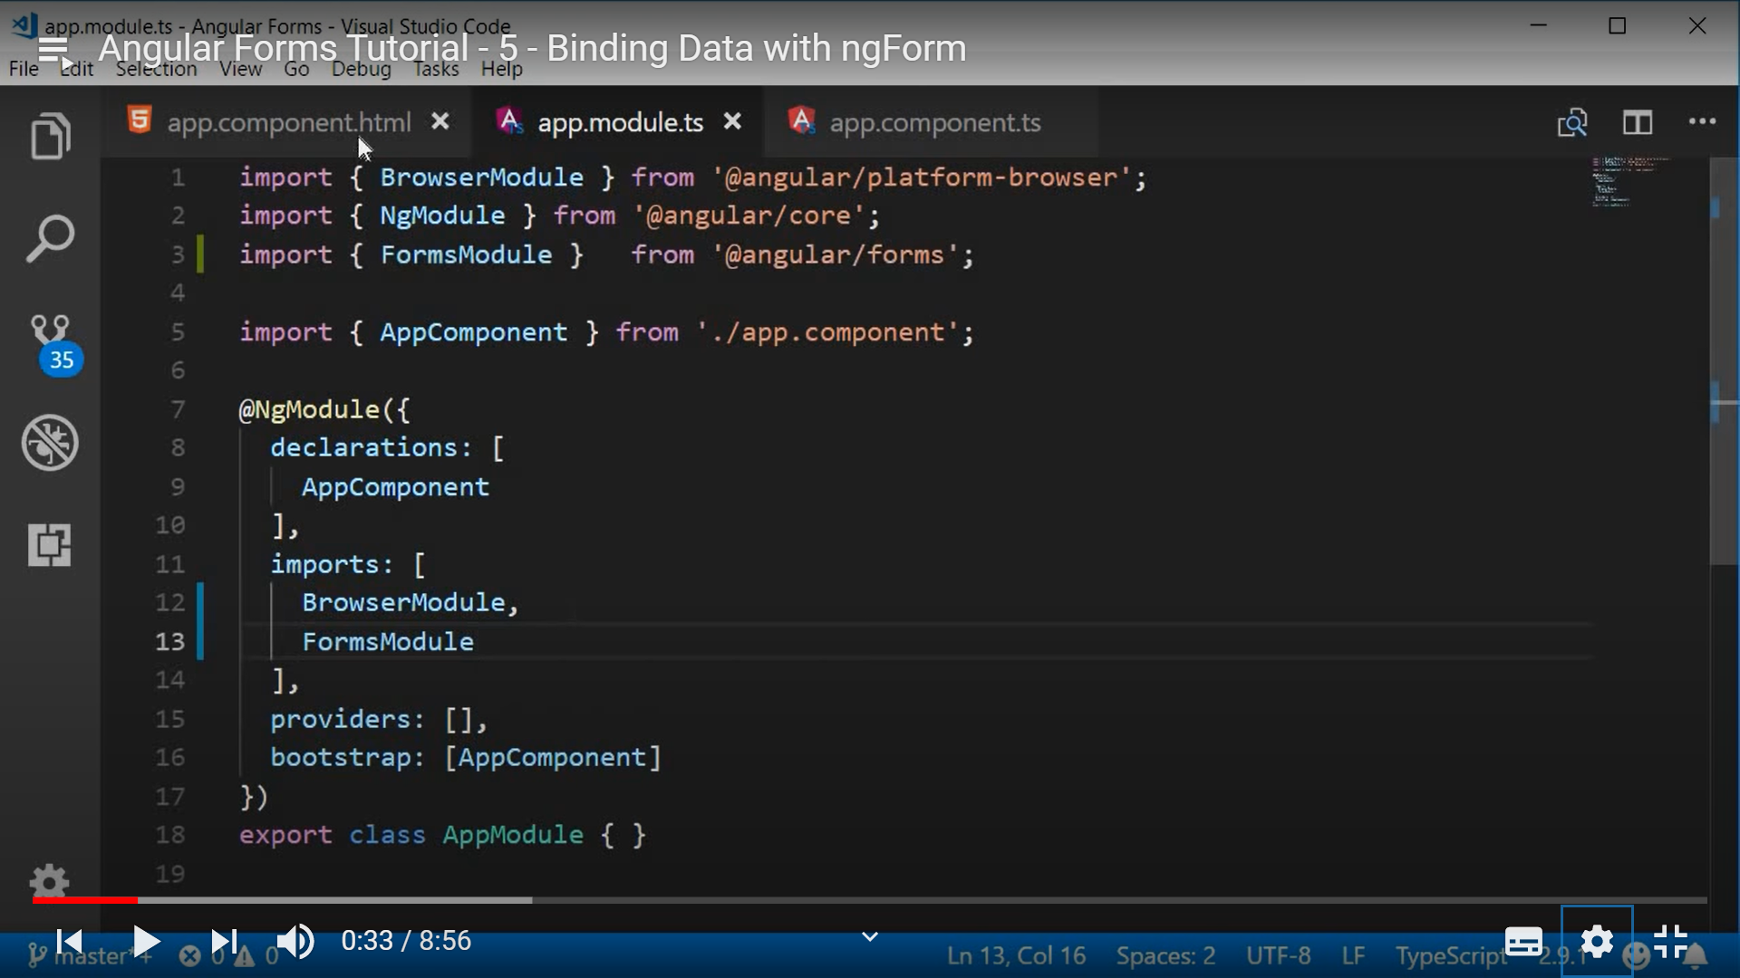

There are three kinds of directives in template driven forms.

1.ngForm 2.ngModel ng

**1.ngForm:**

Angular attaches ngForm directive to the form anytime which gives us valuable information about that particular form. It tells what the value of the different form-controls. ngForm directive exports it self as a String and by assigning it to template reference varible we will have reference to the directive. Using that directive and value property we can acces form control.

**2.ngModel:**

ngModel directive let the angular know that which form control has to be tracked.

**3.ngModelGroup:**

If you want to group all the fileds we can use ngModelGroup directive.

For example take address as a group and street, zipcode, city, state as a elemets in the address group.

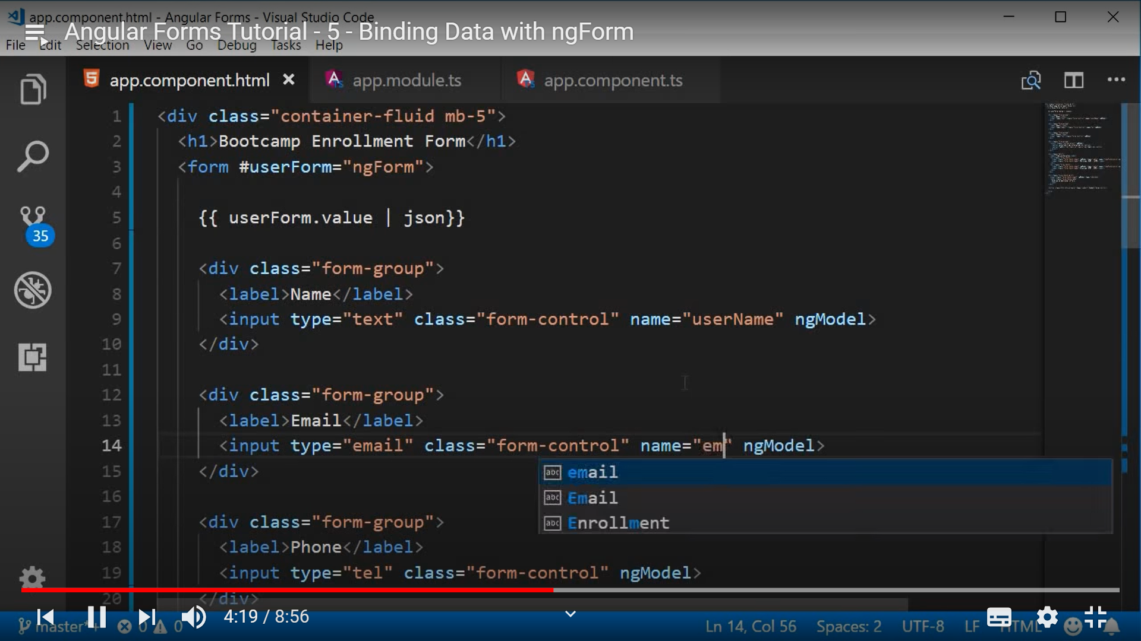

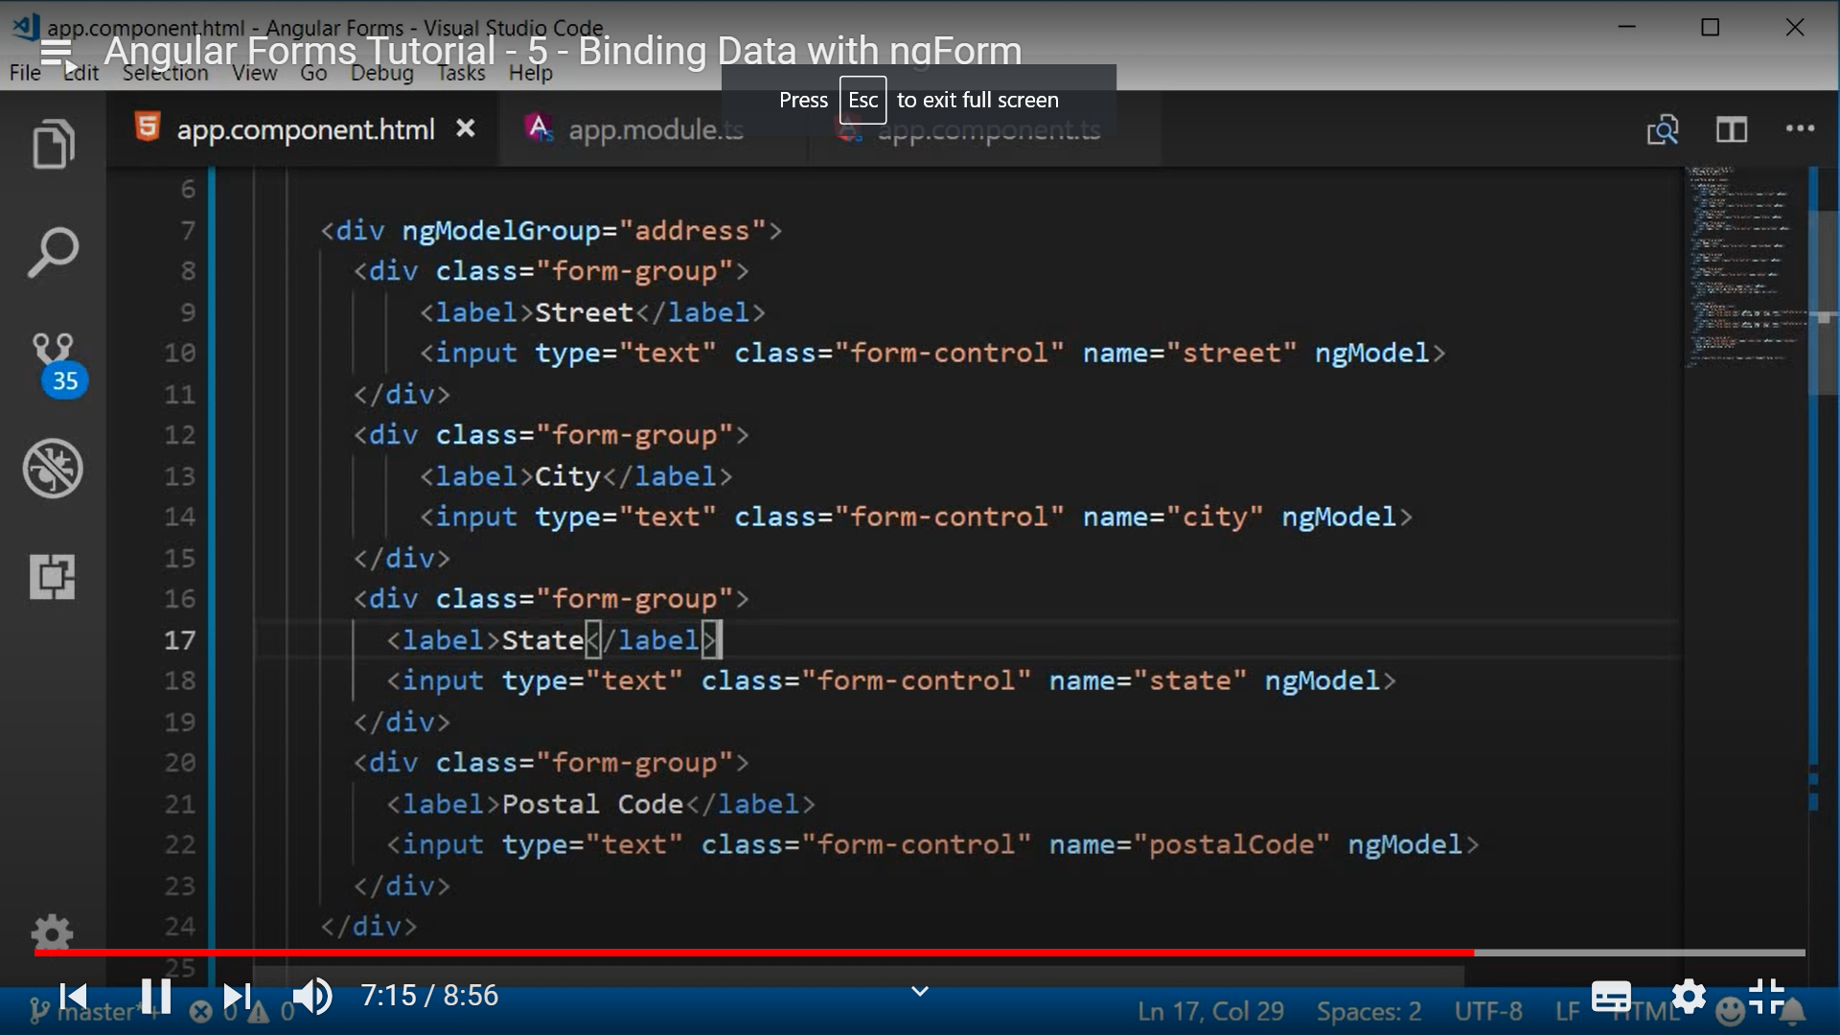

To generate any class cmd : ng generate [class class_name]

**Binding form data to a model class**

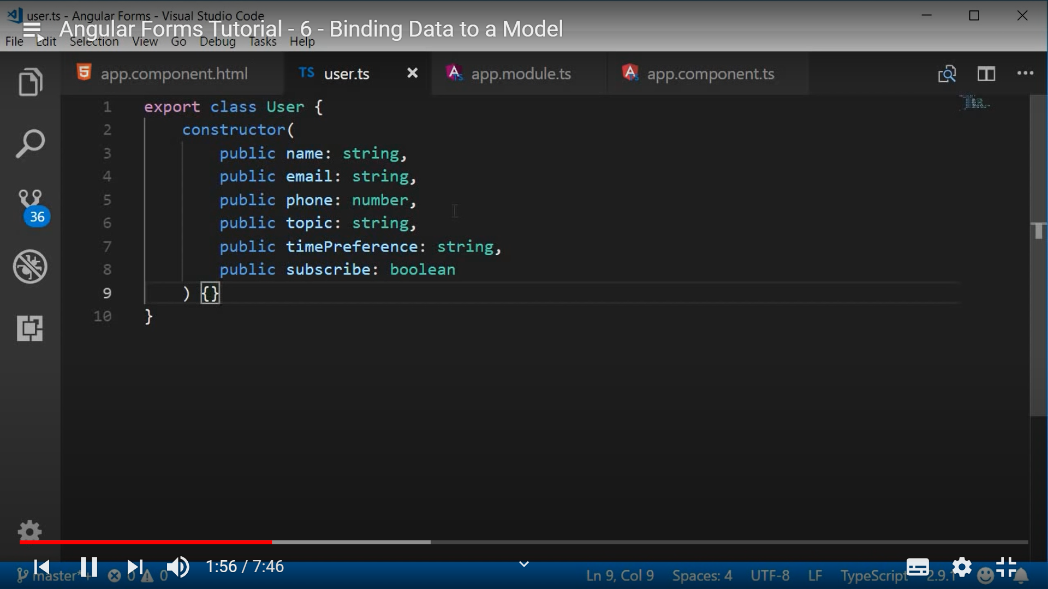

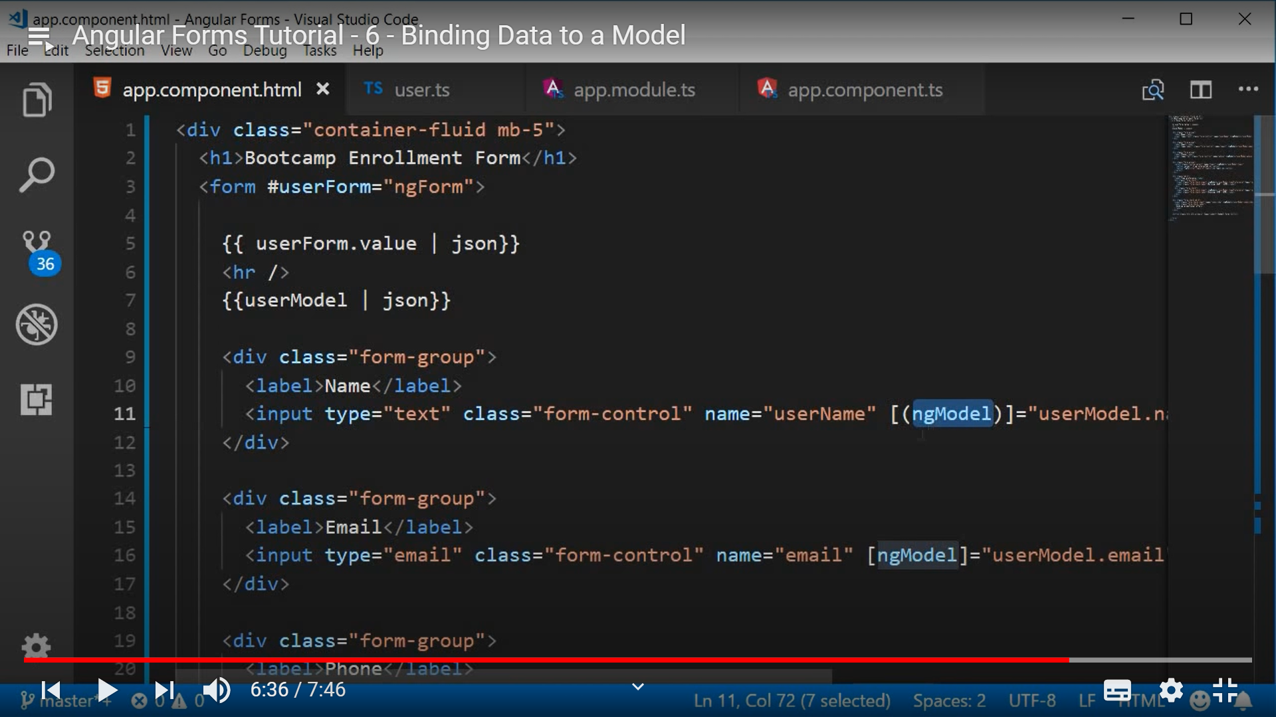

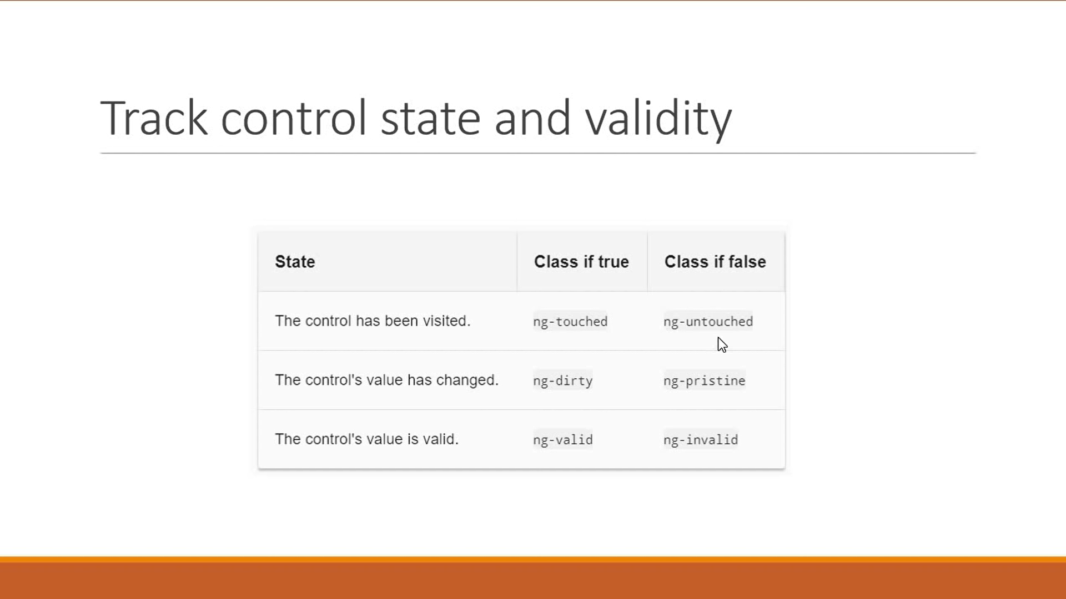

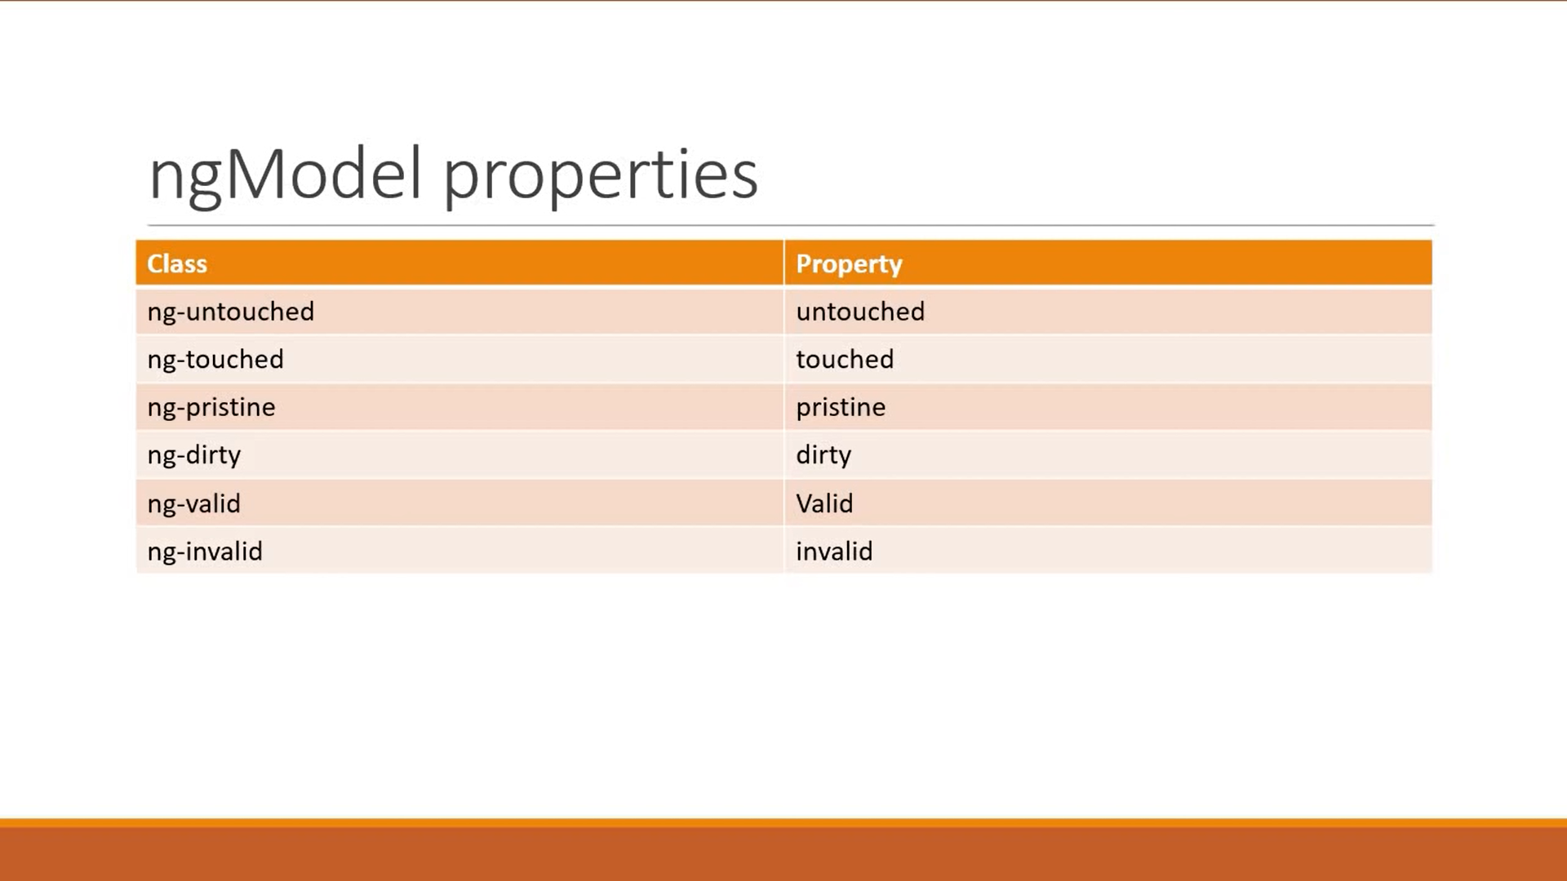

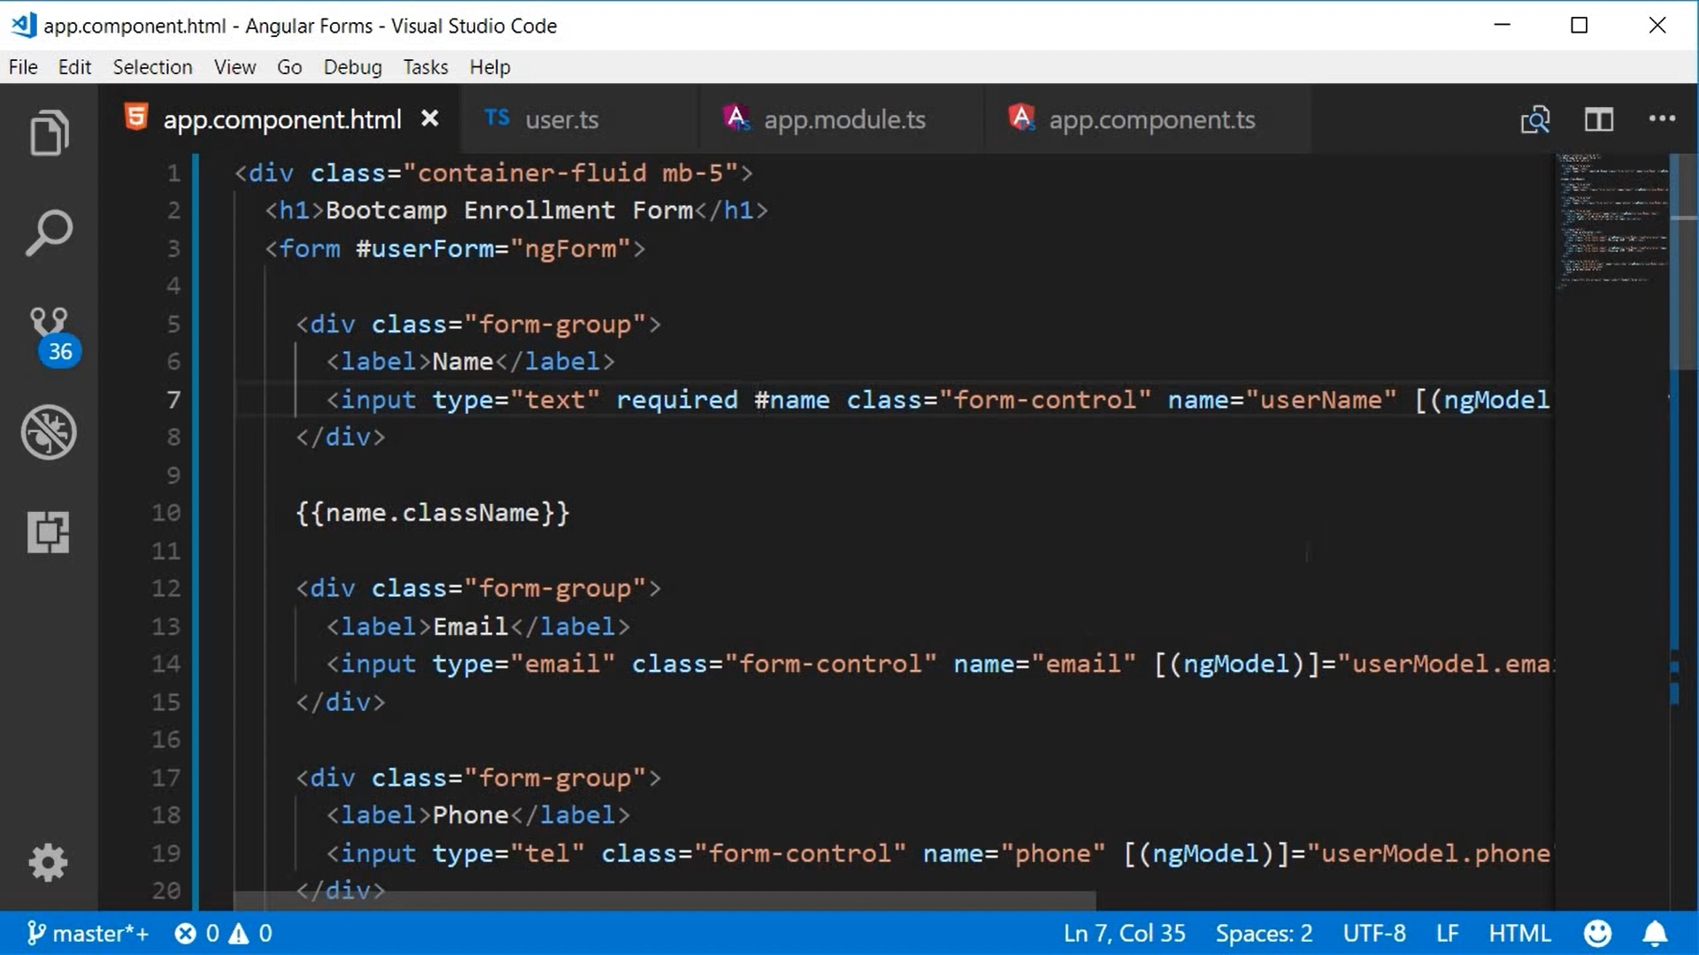

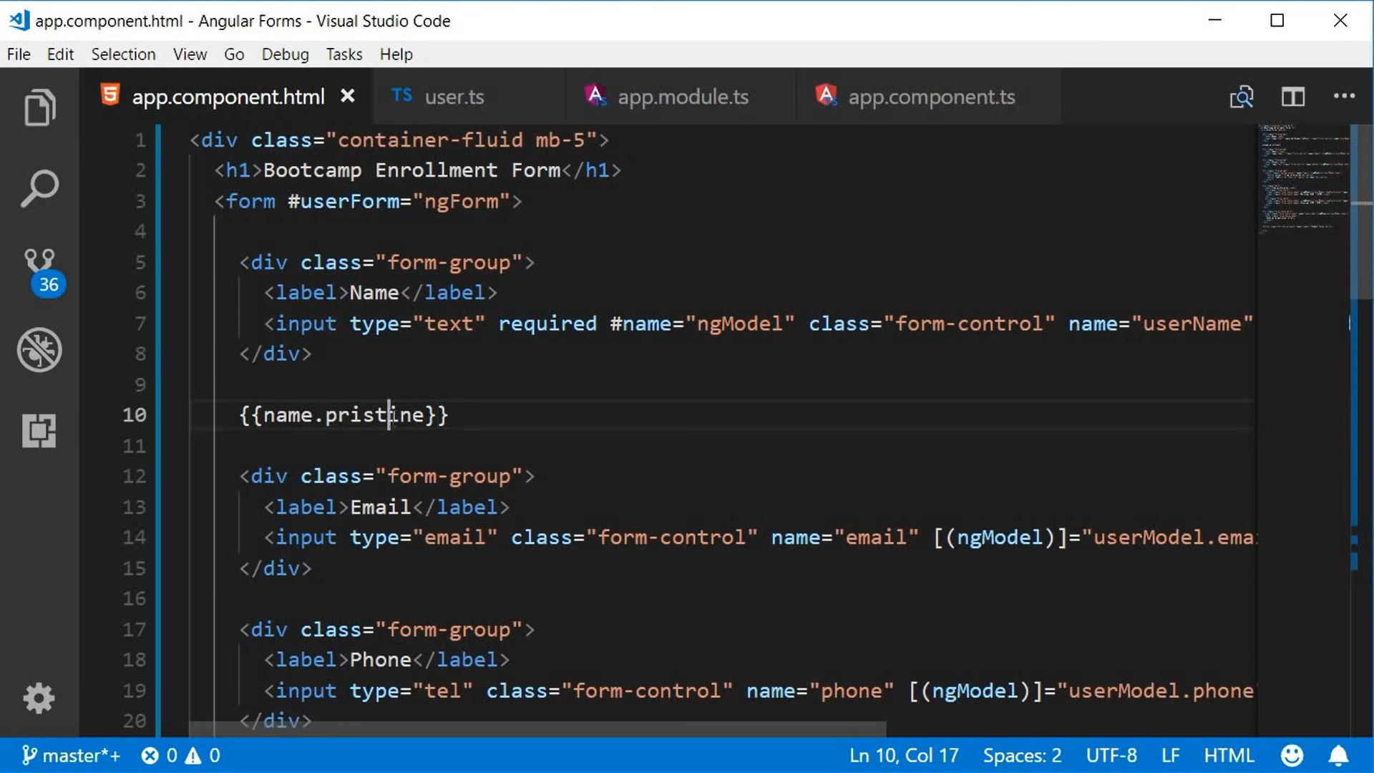

We can use bootstrap class or our own defined class to display the error messages conditionally.

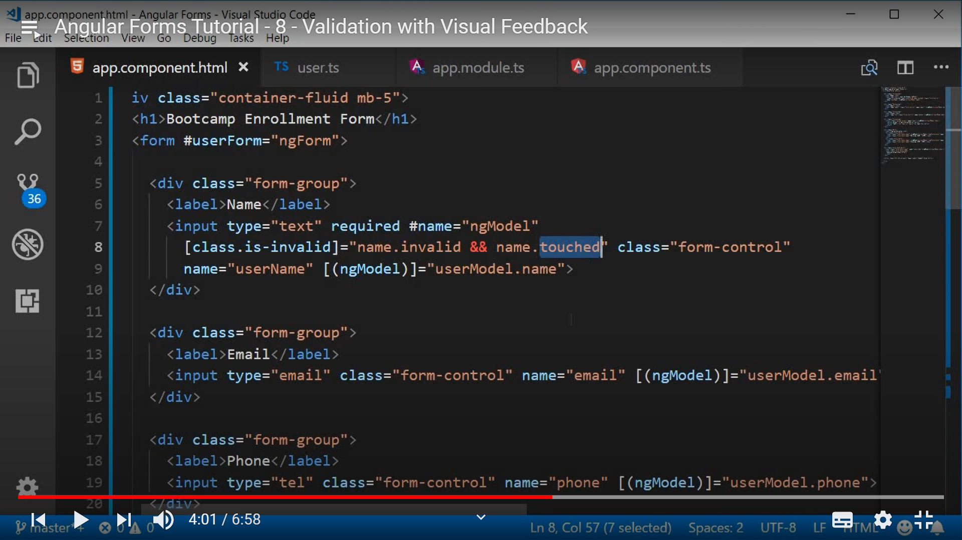

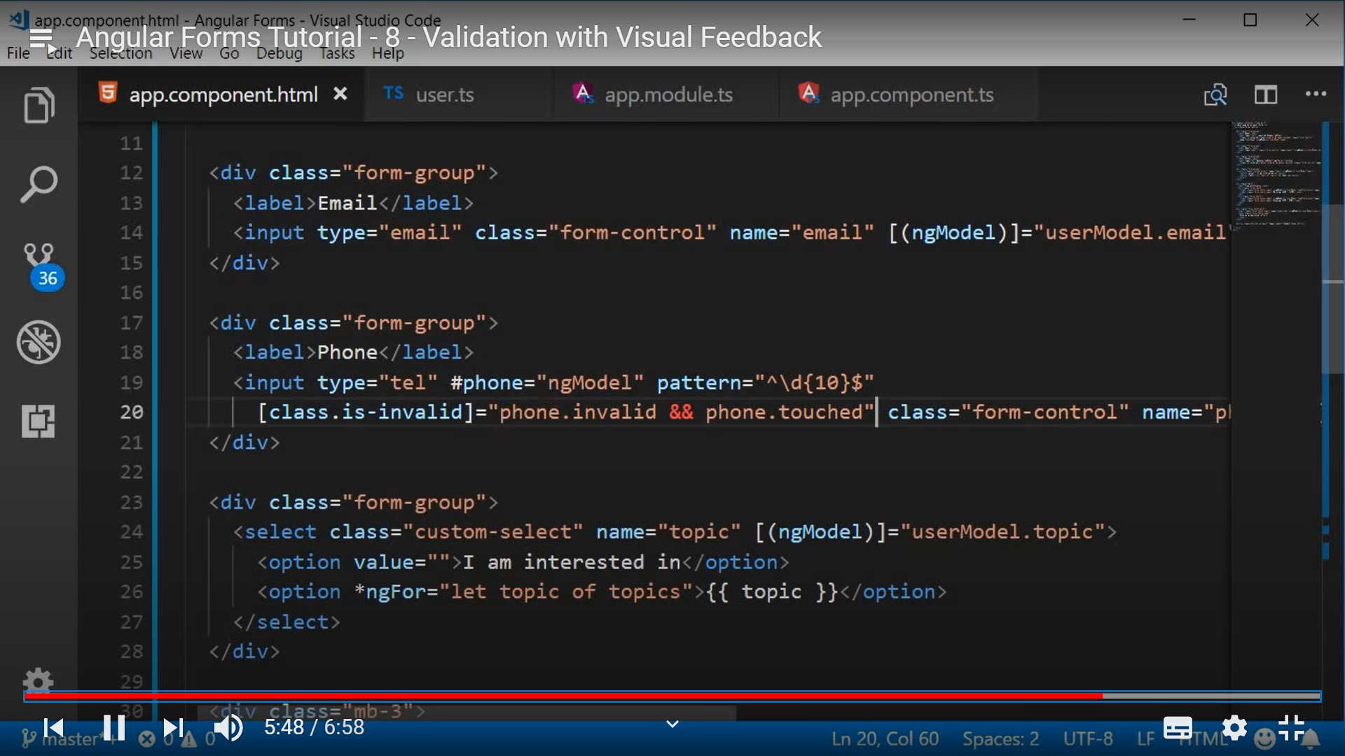

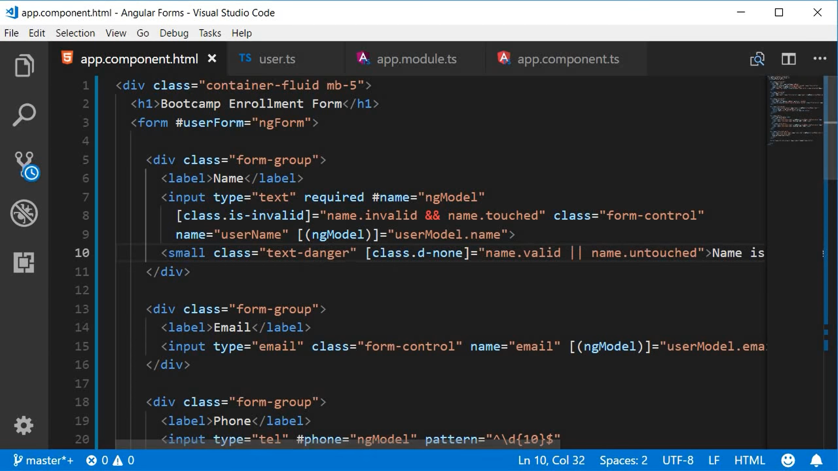



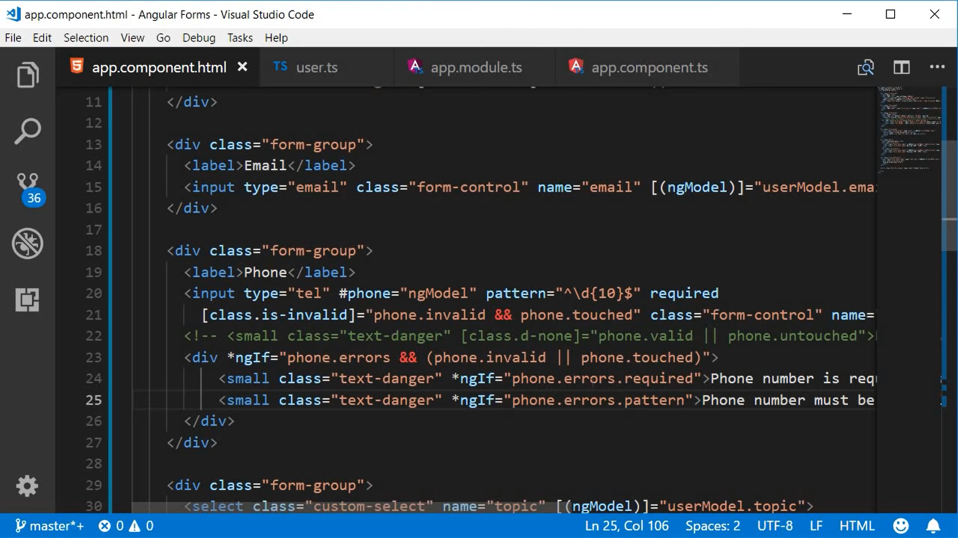

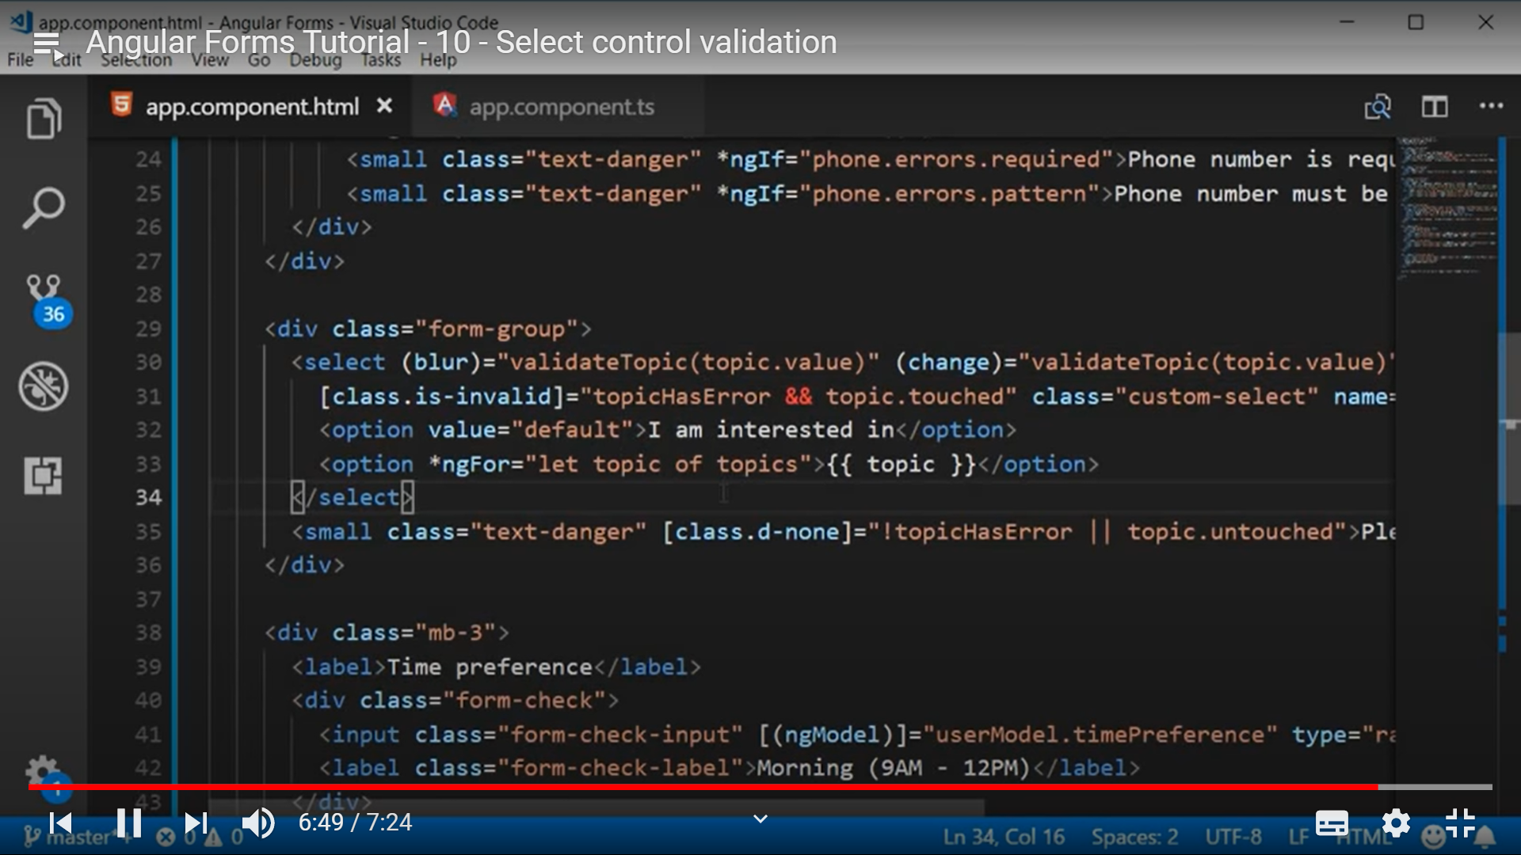

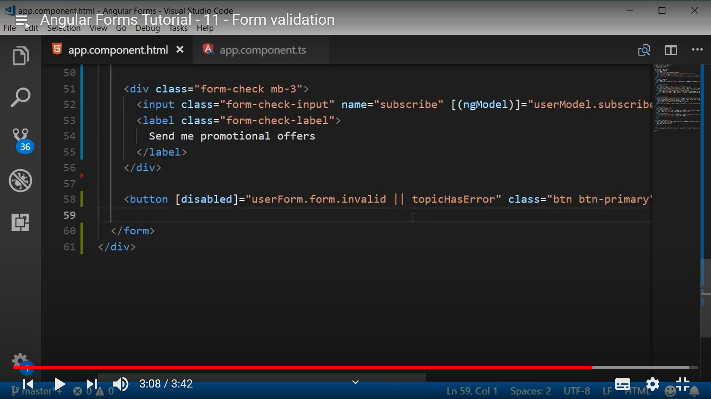

To create a service in angular CLI: ng g s [serviceName]

